**A**

**Project Report**

**On**

***Hospital Management System***

Submitted in partial fulfillment of the requirements for the award of degree

**Bachelor of Computer Application**

From

**Hemchand Yadav Vishwavidyalaya, Durg (C.G.)**

**Year : 2019-2020**



**Guided By:- Submitted By:-**

**Mrs. Smita Daniel Shubhra Bhattacharya**

**Enroll no: DU1739020899**

**Submitted to**

**St. Thomas College, Bhilai**

**Hemchand Yadav Vishwavidyalaya, Durg (C.G.)**

**CERTIFICATE OF APPROVAL**

This is to certify that Project work entitled **“Hospital Management System”** is carried out by **Shubhra Bhattacharya**, a student of **BCA –III year** at **St. Thomas college, Bhilai** is hereby approved as a credible work in the discipline of **Computer Science & Information Technology** for the award of degree of **Bachelor of computer Application-III year** during the session **2019-** **2020**  from **Hemchand Yadav Vishwavidyalaya,Durg (CG).**

**Dr. Suja Varghese**

**(Head Name)**

**CERTIFICATE OF PROJECT GUIDE**

This is to certify that the project report entitled **“Hospital Management System”** submitted to **St. Thomas College ,Bhilai** by **Shubhra Bhattacharya** Enroll no. **DU1739020899** in partial fulfillment for the requirements relating to nature and standard of the award of **BCA-III year** degree by , **Hemchand Yadav Vishwavidyalaya, Durg (C. G.)** for the academic year **2019-2020**.

This project has been carried out under my guidance.

**Guided By:- Mrs. Smita Daniel**

**CERTIFICATE OF COMPANY /ORGANIZATION**

This is to certify that **“**Shubhra Bhattacharya**”** is the student of **Bachelor in Computer Application** of **St. Thomas College, Bhilai** affiliated to **Hemchand Yadav Vishwavidyalaya, Durg (C. G.)** has completed her project entitled **“Hospital Management System”** of the organization from 2019 - 2020.

**Signature of the head**

_______________________

**CERTIFICATE OF EVALUATION**

This is to certify that Project work entitled **“Hospital Management System”** is carried out by Shubhra Bhattacharyaa student of **BCA – III year** at **St. Thomas College, Bhilai**, after proper evaluation and examination, is hereby approved as a credible work in the discipline of Computer Science and Information Technology and is done in a satisfactory manner for its acceptance as a requisite for award of degree of **BCA – III year** during the academic session **2019-2020** from **Hemchand Yadav Vishwavidyalaya, Durg (C. G.)**.

**Internal Examiner External Examiner**

**DECLARATION**

This is to certify that the project report entitled **“Hospital Management System”** which is submitted by me in partial fulfillment for the award of degree of **BCA – III year**, **St. Thomas College**, comprises the original work carried out by me.

I further declare that the work reported in this project has not been submitted and will not be submitted, either in part or in full for the award of any other degree or diploma in this institute or any other institute or university.

**Place: Bhilai Name:** Shubhra Bhattacharya **Date: Enroll No : DU1739020899**

**ACKNOWLEDGEMENT**

I acknowledge my gratitude towards my project guide, Head of Mathematics& Computer Science department and principal of the college for giving me an opportunity to submit a project on “Computer Science & Information Technology”. I thank them for their sincere support and guidance.

Last but not the least I would like to thank lab staffs, faculty members, my friends, family members and seniors for helping me to get information’s and getting print outs and images. I thank them for their unconditional love and support.

**INDEX**

* Synopsis of the project
* Main Report
* Objectives & Scope of the project
* Theoretical Background of Project
* Definition of problem
* System Analysis & Design
* System Planning (PERT Chart)
* Methodology adopted, system Implementation & Details of Hardware & Software used
* System maintenance & Evaluation
* Cost and benefit Analysis
* Detailed Life Cycle of the project
  + ERD,DFD
  + Input and Output screen Design
  + Process involved
  + Methodology used for testing
  + Test Report, Printout of the code sheet
* User/Operational Manual-including security aspects, access rights, back up, Control etc.
* Conclusion
* References
* Soft copy of the project on CD

**Synopsis Of The Project**

This project on “**Hospital Management System”** provide complete information

about how to manage doctor and patient data information. Hospital management

system is the computer based application in which it records and manages

student/teacher information. This application can handle appointment facilities,

pharmacy, doctor and patient details report and management of all the

records attached to it.

In this project, NetBeans is used as front end tool and My-Sql (XAMPP) is used as back end tools. It requires window operating system.

Reports will be generated.

This project will be developing for the Hospital Management. It will be possible to manage the Hospital details easily.

**Main Report**

**OBJECTIVE & SCOPE OF THE PROJECT**

* Manual Work has to be reduced . Results to be received quickly. Get Accuracy. Increase Security , speed, storing.
* To Speed up the operation.
* Provide convenience to travelers. Managing and maintaining data becomes easier.
* To appoint doctors easily.
* To maintain the record which helps in every way possible manner. To provide information about hospital.

**DEFINITION OF THE PROBLEM**

* **DATA REDUNDANCY:-**In manual system, it poses quite a big problem because the data has to be maintained in large volumes but in this system,this problem can be overcome by providing the condition that if the data entered is duplicate, it will not be entered,otherwise,updating will take place.
* **DIFFICULTY IN ACCESSING DATA:-**In manual system,searching information is time consuming but in this system ,any information can be accessed easily through list.
* **UNSATISFACTORY SECURITY MEANS:-**In manual system, no security measures were provided but in this system,password security has been provided.The person can access the system by providing the correct password otherwise he/she is denied the access.

**SYSTEM ANALYSIS**

**“SYSTEM ANALYSIS”** is the first stage of the system development. It consists of identification of the problem to be solved or an opportunity to be taken and then defining the problem and identifying the object for a new system. System analyst seek to study the problem in depth and try to understand all the problems and factors involved in it before suggesting solution for the above.

Several steps we have taken in the System Analysis: - first we have identified the problem or opportunity of the system in order to solve the problem we have studied in their manual system, how many manual register they have kept to maintain and run their system. What are content of the registers? And how they are maintained?

After defining problem and collection data we have sorted our objective and opportunity for the system, which is detailed, defined in “objective of the project”. After sorting out objective and opportunity of the system we presented a proposal to the related firm and explained them about the benefits of the above, in this section we presented all the input screen designs, outputs to the management to verity whether this proposal is beneficial or not in order to maintain their books , members and records properly. With above mentioned task drawn and flow charts for the system.

**SYSTEM ANALYSIS** is vast fields of study through which a system analyst his thought and searched for the best solution of the problem. This is the stage where we are going to collect facts, diagnostic the problem and using the information to recommended improvement of the system. This project is using a system that gives information about the institute and tells the user about works provided by them.

In this phase we will be dealing in the following aspects:-

* Preliminary Study
* Feasibility Report
* Fact-Findings

**PRELIMINARY STUDY**

The first step in the system development life cycle preliminary investigation to determine the feasibility of the system the work preliminary investigation is to collect the information that helps us to evaluate the merits of the project request and make an information judgment about the feasibility of rhe proposed project. While working with preliminary investigation once should accomplish the following.

**Objectives**

* Clarify and understood the project request.
* Determine the size.
* Asses cost and benefits of alternative approaches.
* Determine the technical and operation feasibility.

Here it becomes important that the project should be examined and clarified properly before considering system investigation.

The cost of the project is going to be low because his does not need a number of programmers and a number of software rather this project can be accomplished easily. On technical side this project and team member, thus this project is easy to handle. This project is operational feasible as this do not have any sort of complicated operational to perform. Only a team of seven or eight person can complete this project.

* **FEASIBILITY STUDY**

An initial investigation terminates in a proposal that determines whether an alternative system is feasible. Feasibility study is to check the viability of the project under consideration. Feasibility study can be categorized into three major Parts:-

1. **TECHNICAL FEASIBILITY**

* The proposed system has technical capacity of required to hold the data.
* This project is efficient and responds quickly for various enquire regardless.
* Of number of locations.
* The system proposed could be expanded easily and efficiency, whenever required.

1. **OPERATING FEASIBILITY STUDY**

The management of the organization has a fully supported us to bring up the project and the data security in this project provided by setting up the password procedure so that only the authorized user can access the system.

1. **OUR PROJECT IS ECONOMICAL FEASIBLE AS**

* It has computerizes paper works and also is reduced to large extent
* With the help of this project single person is now available to do the task of 5 to7 persons.
* Due to processing speed of then computer, we can extract desired information’s in a fraction of second.

1. **ECONOMICAL FEASIBLE STUDY**

Economical analysis uses technique for evaluating the effectiveness of a proposed system. It determines the benefit and saving that are expected from the proposed system and compares them with cost. If benefits out weight cost, the system analysis because it is cost that matter more in setting any system.

1. **SOCIAL FEASIBILITY**

Social feasibility is determination of whether a proposed will be accepted to the people or not. This determine typically examines the probability of the project being accepted b the group directly affected by the proposed system change.

1. **MANAGEMENT FEASIBILITY**

It is a determination of whether a proposed will be acceptable to the management. If management does not accept a project all gives negligible support to it, the analyst will tend top you the project as a non-feasible one regarding our project is assume that the project will be accepted because it will help the management a lot by saving time and man power wasted in to in paper work.

1. **LEGAL FEASIBILITY**

Legal feasibility is a determination of whether a proposed infringes on known act as well as any pending legislature. Although in some instance the project might appear sound, on closer investigation it may be formed infringes on several legal areas.

1. **TIME FEASIBILITY**

Time feasibility is determination of whether a proposed project can be implemented fully within the stipulated time frame. If a project takes too much time it OS likely to be rejected. Thus if project can be completed in time then only considered further also Dropped.

* **FACT FINDINGS**

Fact findings mean learning as much as possible about the present system. To do the fact finding the following things are done:-

* Interview personals
* Prepare questionnaires
* Observe the current system
* Gather document frontally in use
* Determine the flow of data
* Clearly define the system requirement

The new system may be built a fresh or by changing the existing system. Development being by defining a model of new system a continuous by converting this model to a system in a short analysis specifies what the system should do.

**SOFTWARE & HARDWARE REQUIREMENTS**

**HARDWARE SPECIFICATION**

**1**. PROCESSOR : Intel Core2Duo or Higher

**2**.RAM : 2 GB

**3**.HARD DISK : 100 GB

**4**.MONITER : 15.1”SVGA

**5**.GRAPHICS CARD : 512 MB or higher

**6**.CD DRIVE : 52 X CDROM

**7**.KEYBOARD : 108 KEYBOARD

(MULTIMEDIA)

**8**.PRINTER : HP LASER JET 2000

**9**.MOUSE : SCROLL MOUSE

**SOFTWAREE SPECIFICATION**

**1**. OPERATING SYSTEM : WINDOWS 10

**2**.RDMS : MySQL(XAMPP) -> BACKEND

**3**.SOFTWARE PACKAGE : NetBeans 8.2 🡪FRONTEND

**SYSTEM PLANNING (PERT)**

Program evaluation and review technique (PERT) and the critical path method (CPM) are two project scheduling methods that can be applied to software development. These techniques are driven by information already developed in earlier project planning activities.

* Estimates of effort.
* A decomposition of the product function.
* The selection of the appropriate process model & task set.
* Decomposition of tasks.
* Interdependencies among tasks may be defined using a task network.

Tasks, sometimes called the project work breakdown structure (WBS), are defined for the product as a whole or for individual functions.

PERT provide quantitative tools that allow the software planner to:

* Determine the critical path- the chain of tasks that determine the duration of the project.
* Establish “most likely” time estimates for individual tasks by applying statistical model
* Calculate “boundary times” that define a time “window” for a particular task.

**METHODOLOGY ADOPTED**

**&**

**SYSTEM IMPLEMENTATION**

The technology provides the foundation for the data & application architectures. The infrastructure encompasses the hardware & software that are used to support the application & data. This includes computers, operating systems, network telecommunication links, storage technologies & the architecture that has been designed to implement these technologies. The technology drivers’ incremental changes must be co-coordinated across a distributed environment consisting of hardware & software. Computer Laboratory Management System is implemented by the help of Front end and back end tools.

**SYSTEM DESIGN**

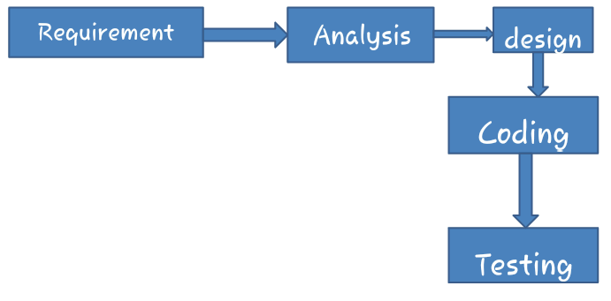

System Design is the most creative thing in the system life cycle. Design is the first step into the development of any system. Design is the creative process. A good design is a key of effective system. System design is a solution how to approach creation of new system. System design transform a logical representation into the physical specification.

LOGICAL DESIGN

Reviews the current physical system.

Prepare output specification.

Prepare input specification.

Prepare edit, security and control specification .

Specifies the implementation plan.

Review befits and system constraints.

PHYSICAL DESIGN

1. Design the physical system.
2. Specifies input and output media.
3. Design the database and specify the backup procedure.
4. Plan system implementation.
5. Problem understanding
6. High level requirements proposal.

INPUT DESIGN

Input design deals with what data should be given as output, how the data should be arranged, methods for preparing inputs and steps to follow when error occurs. Input design is a process of coverting a user oriented description of the input into a computer based system. This design is important to avoid errors in the data inpit process and show the correct direction to the management for getting correct information. It is to achieved by creating user friendly screens for the data entry to handle large volume of data. The goal of designing input is to make data entry easier and to be free from errors.

When the data is entered it will check for its validity. Data can be entered with help of screens.

In this project, the input design consist of a login screen and many other types are also available.

**SYSTEM MAINTENANCE & EVALUATION**

**System Maintenance** is necessary to eliminate errors in the working system during its working life and to tune the system to any variations in its working environment. Often small system deficiencies are found, as a system is brought into operation and changes are made to remove them. System planners must always plan for resource availability to carry out these maintenance functions. The importance of maintenance is to continue to bring the new system to standards. Project requires both maintenance of hardware and software. Implementation is the process of having systems personnel check out and put new equipment into use, train users, install the new application and construct any files of data needed to use it. This phase is less creative than system design.

**Evaluation of the system** is performed to identify its strength and weaknesses. The actual evaluation can occur along any one of the following dimensions: Operational Evaluation isassessment of the manner in which the system functions. Organizational Impact isIdentification and measurement of benefits to the organization. User Manager Assessment is Evaluation of the attitudes of senior manager and user within the organization, as well as end users. Development Performance is Evaluation of the development process in accordance with development time and effort.

**COST AND BENEFIT ANALYSIS**

Cost/benefit analysis measures cost and benefit in the system development and implementation. It includes hardware, personal, facility, operating and supply costs. Hardware Costs incurred in purchase of hardware, i.e. computer and its peripherals. Personnel Costs include the salaries of the EDP staff, as well as the perks of personnel involved in the development of the system. Facility Costs include expenses incurred in the preparation of the physical site. This includes flooring, wiring, lighting, etc. Operating costs include all costs associated with the day to day operations of the system. Supply costs include variable costs that increase with increased use of paper, ribbon, disks, etc. The system is also expected to provide benefits. Benefits may be tangible or intangible, fixed or variable, direct or indirect. The benefits of a project include four types:

1. **Cost-Saving benefits**: It leads to reduction in administrative and operational costs. A reduction in the size of the clerical, staff used in the support of an administrative activity is an example of a cost saving benefit.
2. **Cost-avoidance benefits**: It eliminates future administrating and operational costs. No need to hire additional staff in future to handle an administrative activity is an example of cost-avoidance benefit.
3. **Improved-service-level benefits**: It improves performance of a system is improved by a new computer-based method.
4. **Improved-information benefits**: It is where computer based methods lead to better information for decision-making.

**CATEGORIES OF COSTS AND BENEFITS**

The costs associated with the system are expenses, outlays or losses arising from development and using a system. But the benefits are the advantages received from installing and using this system. Costs and Benefits can be classified as follows:

1. **Tangible or Intangible**: Tangibility refers to financial value be exactly measured. Costs that cannot be exactly measured are referred to as an intangible costs.
2. **Direct or indirect costs and benefit**: Direct costs are directly associated with a system. They are applied directly to the operator. Indirect costs are not directly associated with a system. They are often referred to as overhead expenses.
3. **Fixed or variable costs and benefits**: Fixed costs are considered as sunk costs. Once encountered, they will not recur. Variable costs are incurred on a regular basis.

**DATAFLOW DIAGRAM**

A data flow diagram is graphical tool used to describe and analyze movement of data through a system. These are the central tool and the basis from which the other components are developed. The transformation of data from input to output, through processed, may be described logically and independently of physical components associated with the system. These are known as the logical data flow diagrams. The physical data flow diagrams show the actual implements and movement of data between people, departments and workstations. A full description of a system actually consists of a set of data flow diagrams. Using two familiar notations Yourdon, Gane and Sarson notation develops the data flow diagrams. Each component in a DFD is labeled with a descriptive name. Process is further identified with a number that will be used for identification purpose. The development of DFD’s is done in several levels. Each process in lower level diagrams can be broken down into a more detailed DFD in the next level. The lop-level diagram is often called context diagram. It consists a single process bit, which plays vital role in studying the current system. The process in the context level diagram is exploded into other process at the first level DFD.

The idea behind the explosion of a process into more process is that understanding at one level of detail is exploded into greater detail at the next level. This is done until further explosion is necessary and an adequate amount of detail is described for analyst to understand the process.

Larry Constantine first developed the DFD as a way of expressing system requirements in a graphical from, this lead to the modular design.

A DFD is also known as a “bubble Chart” has the purpose of clarifying system requirements and identifying major transformations that will become programs in system design. So it is the starting point of the design to the lowest level of detail. A DFD consists of a series of bubbles joined by data flows in the system.

**DFD SYMBOLS:**

In the DFD, there are four symbols

A square defines a source (originator) or destination of system data

1. An arrow identifies data flow. It is the pipeline through which the information flows
2. A circle or a bubble represents a process that transforms incoming data flow into outgoing data flows.
3. An open rectangle is a data store, data at rest or a temporary repository of data.

Process that transforms data flow.

Source or Destination of data

Data flow

Data Store

**CONSTRUCTING A DFD**

Several rules of thumb are used in drawing DFD’s:

1. Process should be named and numbered for an easy reference. Each name should be representative of the process.
2. The direction of flow is from top to bottom and from left to right. Data Traditionally flow from source to the destination although they may flow back to the source. One way to indicate this is to draw long flow line back to a source. An alternative way is to repeat the source symbol as a destination. Since it is used more than once in the DFD it is marked with a short diagonal.
3. When a process is exploded into lower level details, they are numbered.
4. The names of data stores and destinations are written in capital letters. Process and dataflow names have the first letter of each work

capitalized. A DFD typically shows the minimum contents of data

store. Each data store should contain all the data elements that flow in and out.

Questionnaires should contain all the data elements that flow in and out. Iterfaces redundancies and like is then accounted for often through interviews.

**SILENT FEATURES OF DFD’s**

1. The DFD shows flow of data, not of control loops and decision are controlled considerations do not appear on a DFD.
2. The DFD does not indicate the time factor involved in any process whether the data flows take place daily, weekly, monthly or yearly.
3. The sequence of events is not brought out on the DFD.

**ZERO LEVEL DFD :**

DOCTOR MANAGEMENENT

REPORT MANAGEMENT

USER MANAGEMENT

PATIENT MANAGEMENT

SYSTEM USER MANAGEMENT

APPOINTMENT MANGEMENT

MEDICINE MANAGEMENT

RECEPTION MANAGEMENT

**ER DIAGRAM**

**1.MULTILE LOG-IN**

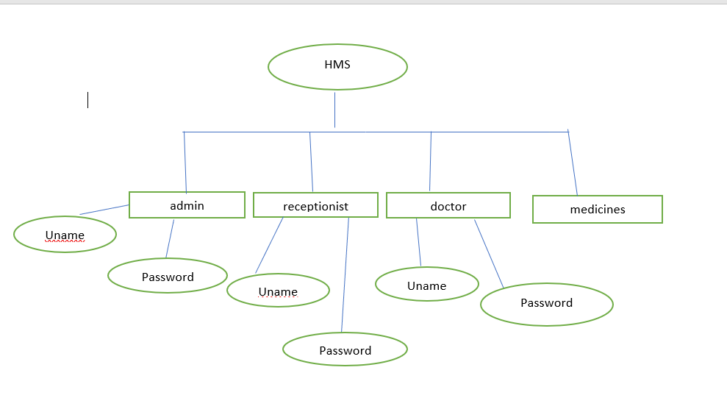

**2.ADMIN LOG-IN**

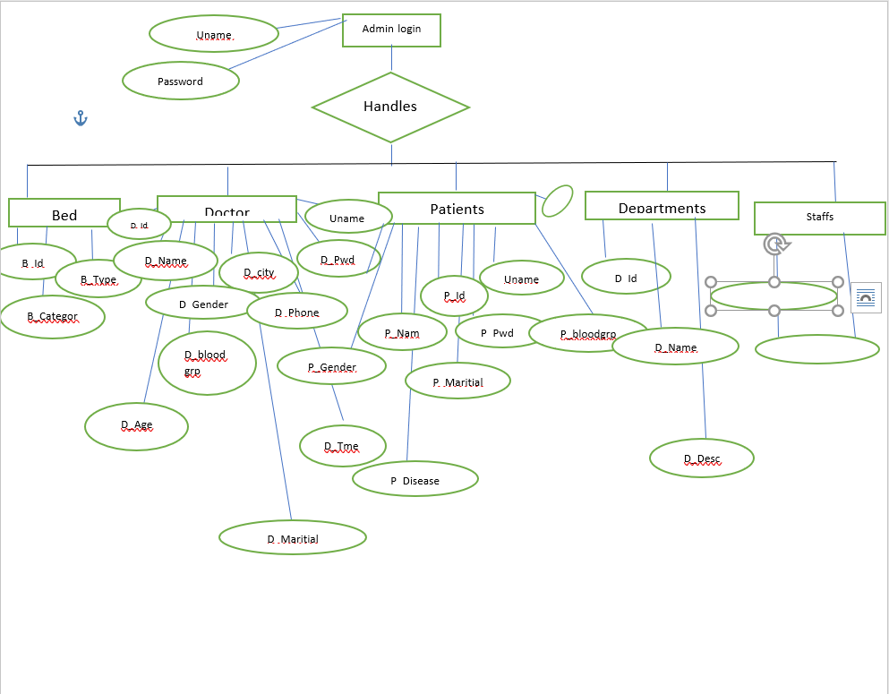

**Input and Output Screen Design**

**DATABASE DESIGN**

Data base management is a collection of interrelated tables. It allows accessing of data and information from more than one table. Table is a collection of fields/columns or records. A field is a collection of data items. Data abstraction is a design stage of the database. There are 3 levels: Physical, Logical and view. Database schema is design way of the database. It is used to list out layout of the software. It is a mirror of the software.

A properly designed database provides you with access to up-to-date, accurate information. Because a correct design is essential to achieving your goals in working with a database, investing the time required to learn the principles of good design makes sense. In the end, you are much more likely to end up with a database that meets your needs and can easily accommodate change.

This article provides guidelines for planning a database. You will learn how to decide what information you need, how to divide that information into the appropriate tables and columns, and how those tables relate to each other. You should read this article before you create your first database.

Certain principles guide the database design process. The first principle is that duplicate information (also called redundant data) is bad, because it wastes space and increases the likelihood of errors and inconsistencies. The second principle is that the correctness and completeness of information is important. If your database contains incorrect information, any reports that pull information from the database will also contain incorrect information. As a result, any decisions you make that are based on those reports will then be misinformed.

A good database design is, therefore, one that:

* Divides your information into subject-based tables to reduce redundant data.
* Provides Access with the information it requires to join the information in the tables together as needed.
* Helps support and ensure the accuracy and integrity of your information.
* Accommodates your data processing and reporting need.

**DATABASE (HOSPITAL MANAGEMENT SYSTEM)**

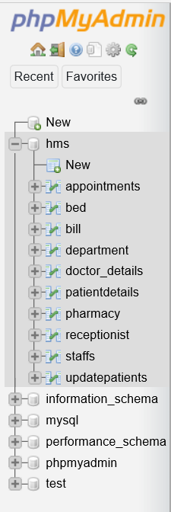

**TABLES:-**

**1.DOCTOR DETAILS**

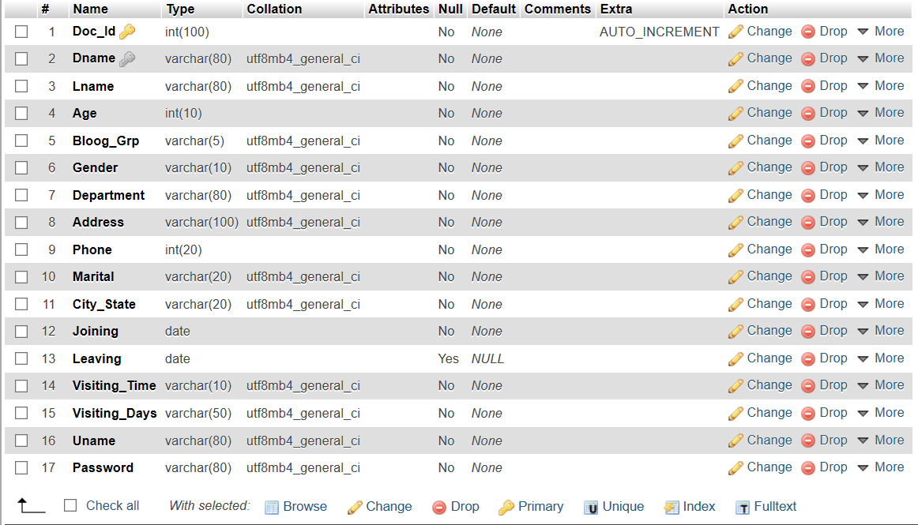

**2.OTHER STAFF DETAILS**

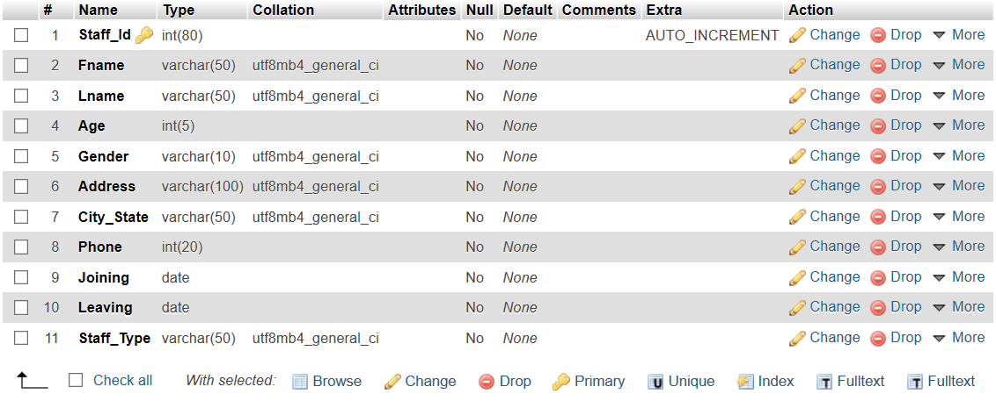

**3.RECEPTIONIST DETAILS**

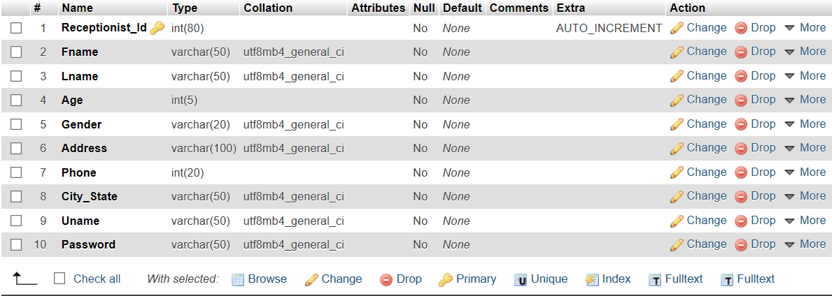

**4.PATIENT DETAILS**

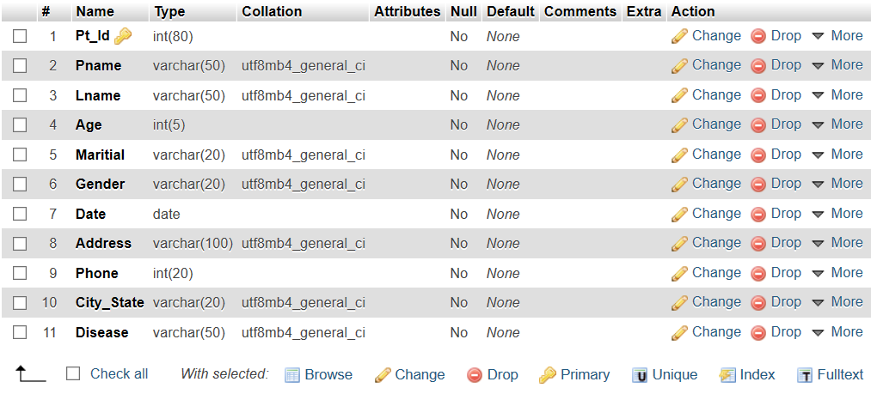

**5.AVAILABILITY OF BEDS**

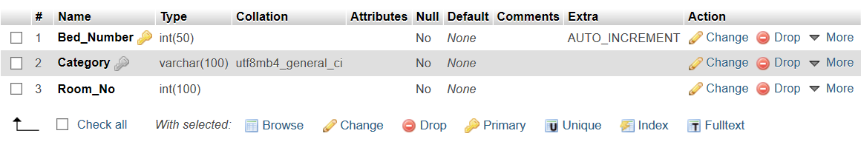

**6.DEPARTMENT DETAILS**

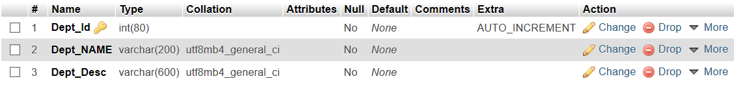

**7.UPDATE PATIENT DETAILS**

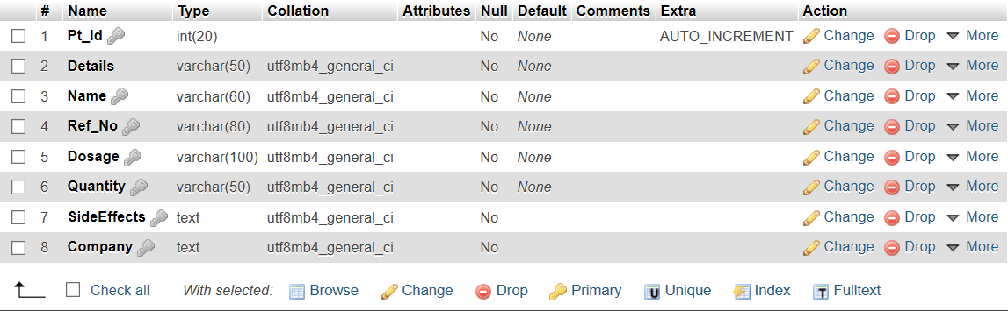

**8.APPOINTMENT DETAILS**

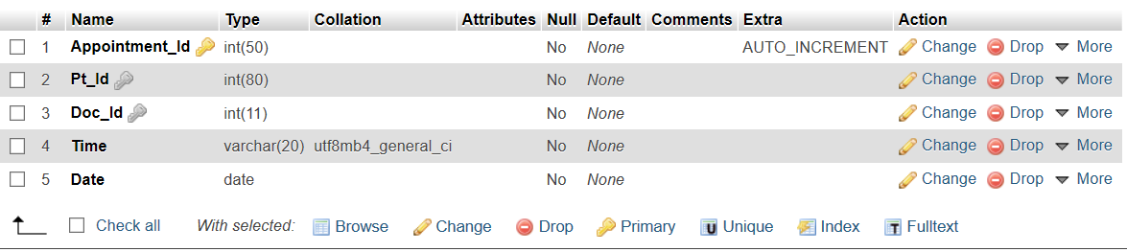

**9.MEDICINE DETAILS**

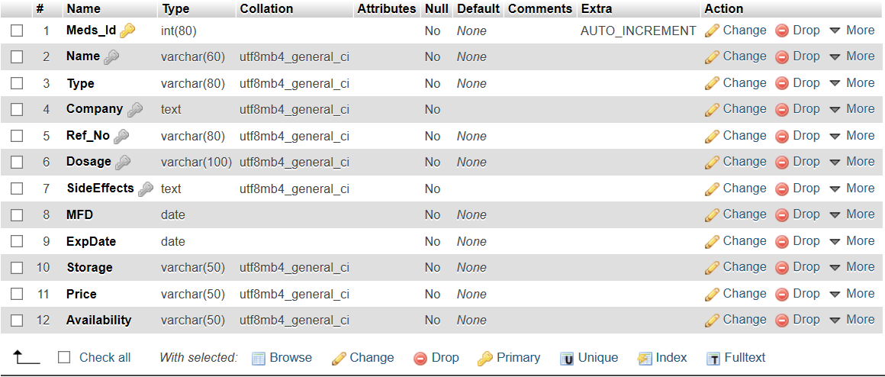

**10.Bill Details**

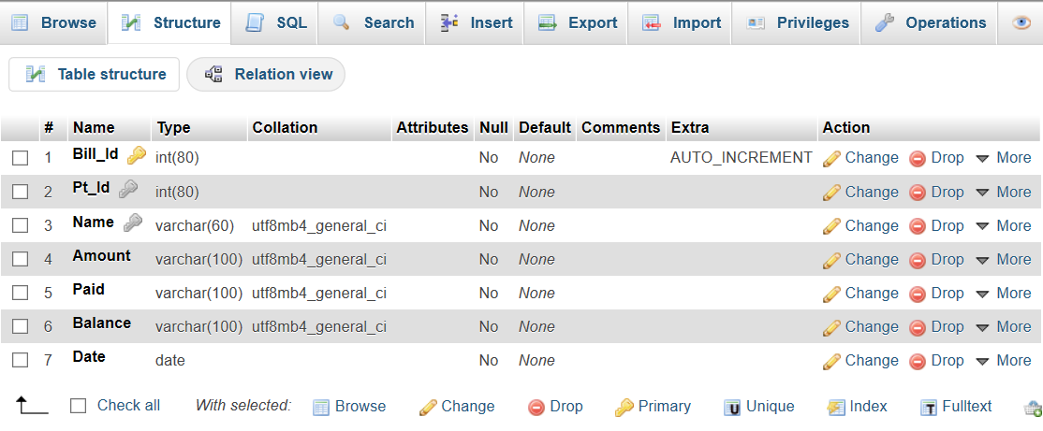

**USER-INTERFACE**

**1.SPLASH**

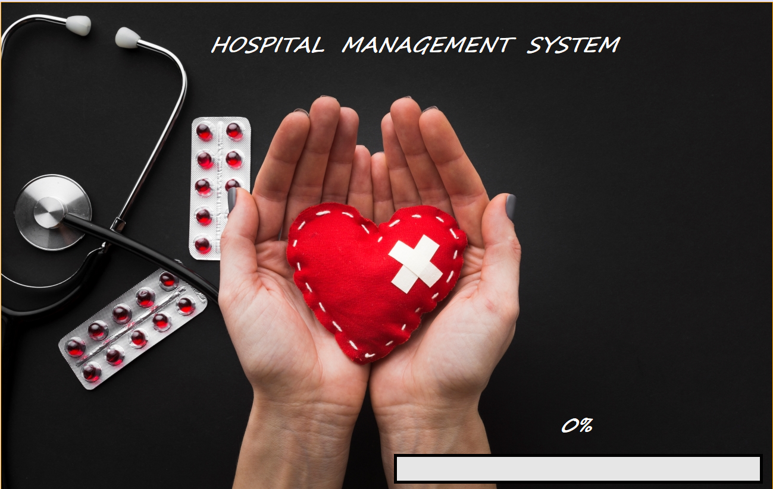

**2.BASIC LOG-IN**

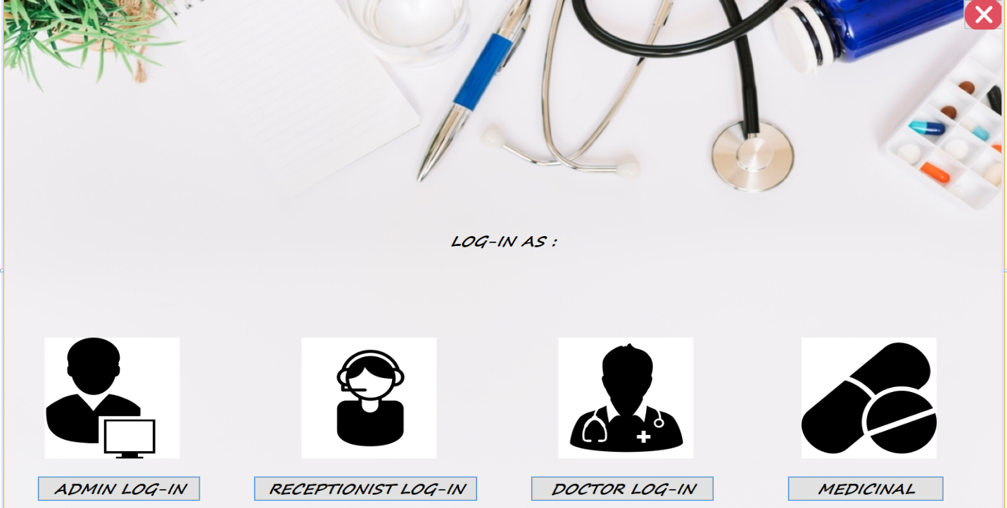

**3.ADMIN LOG-IN**

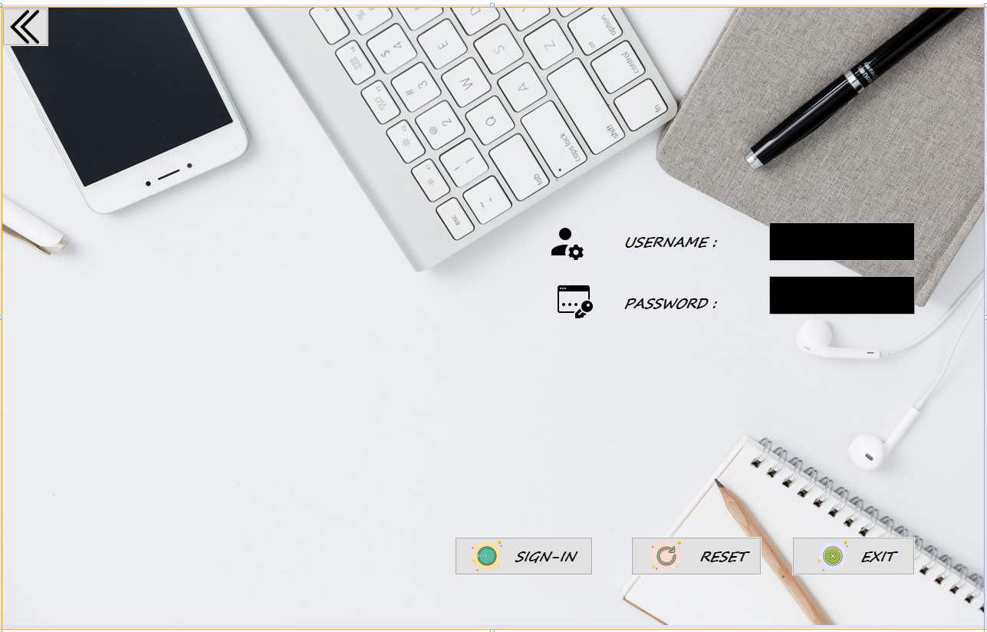

**4.RECEPTIONIST LOG-IN**

**~~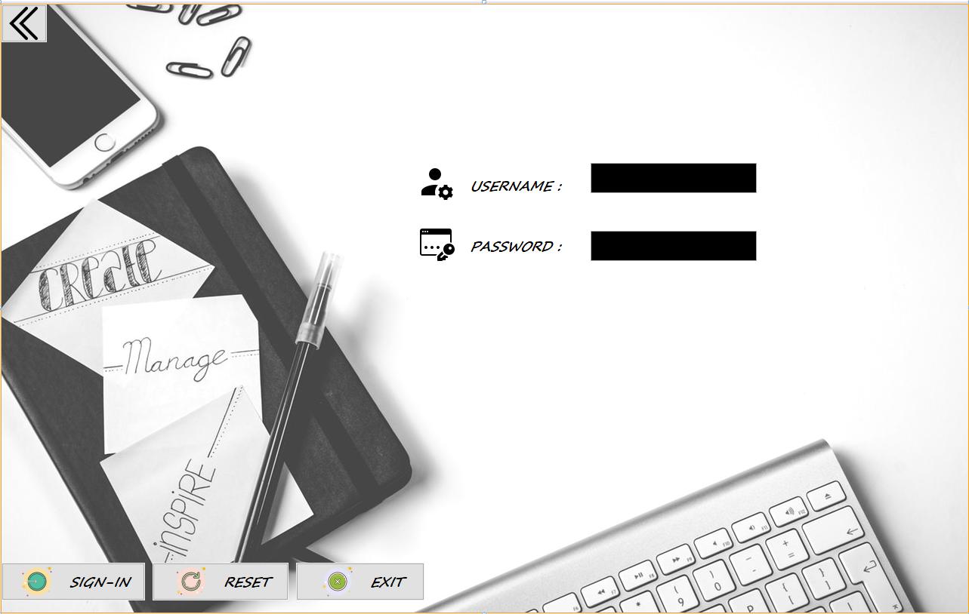~~**

**5.DOCTOR LOG-IN**

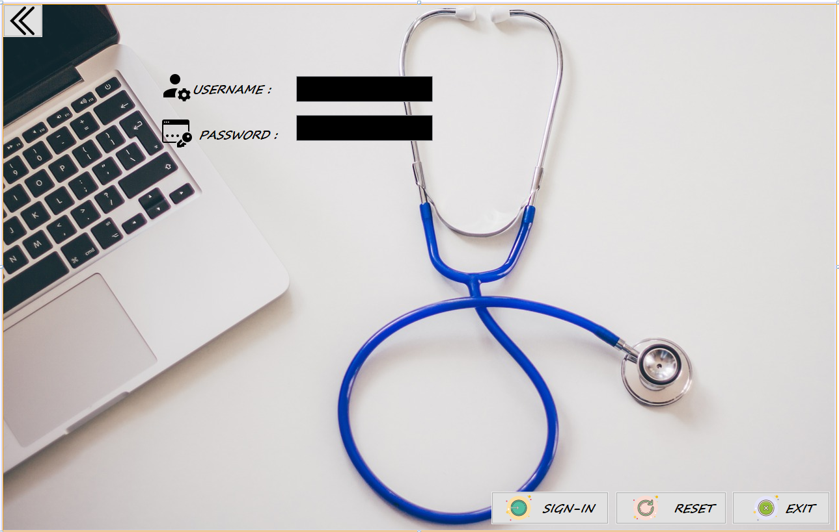

**6. ADMIN PANEL**

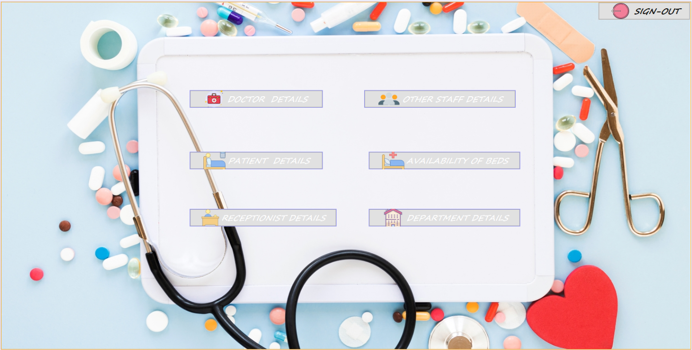

**7.DOCTOR DETAILS**

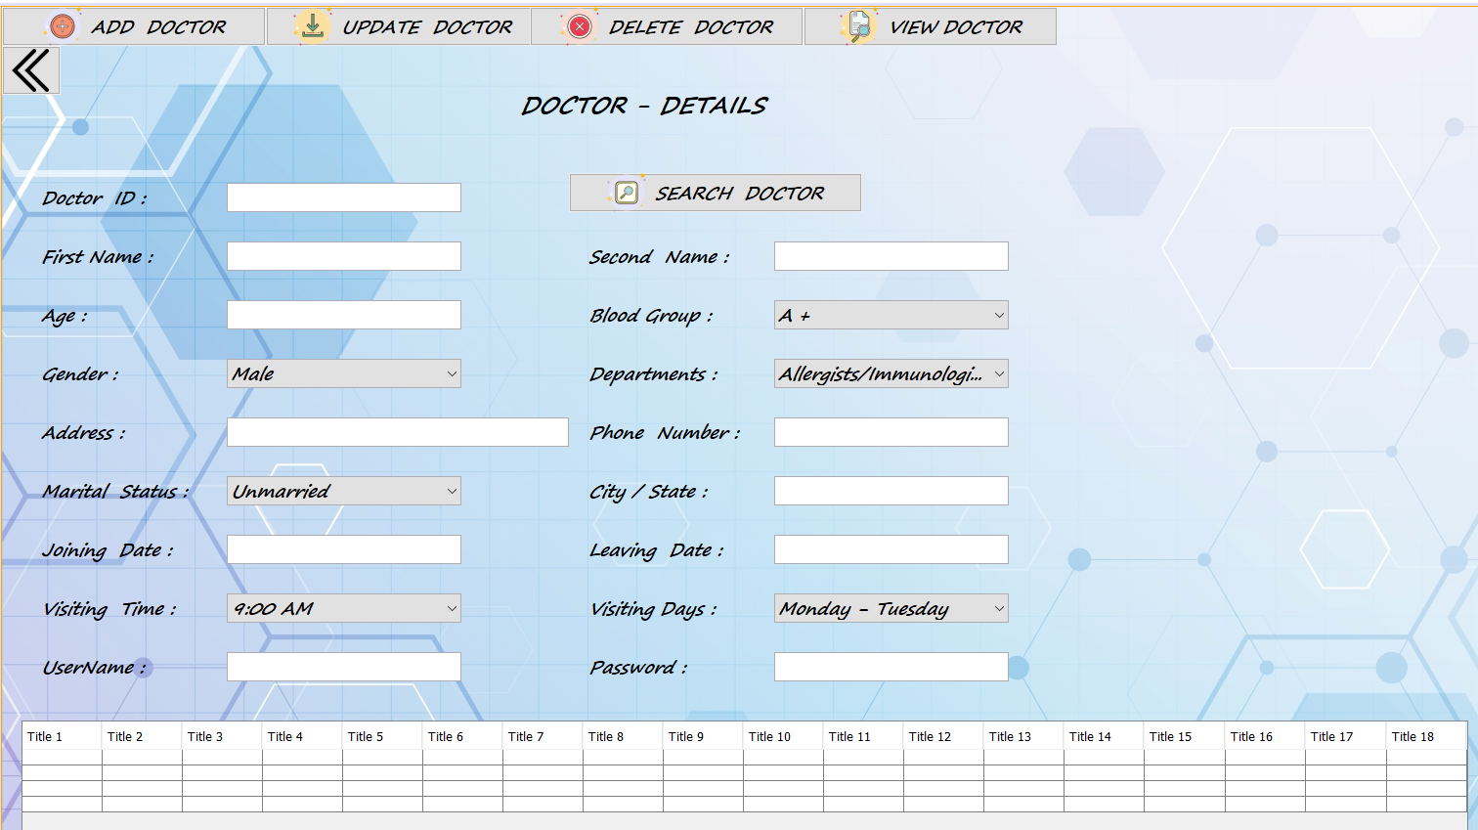

**8.STAFF DETAILS**

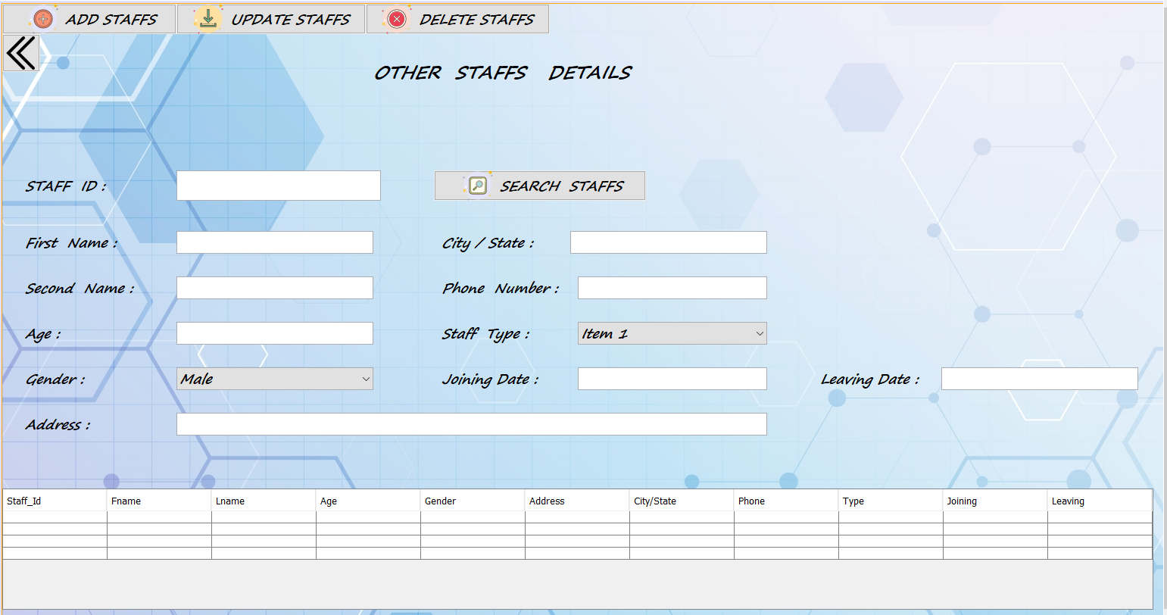

**9.RECEPTIONIST DETAILS**

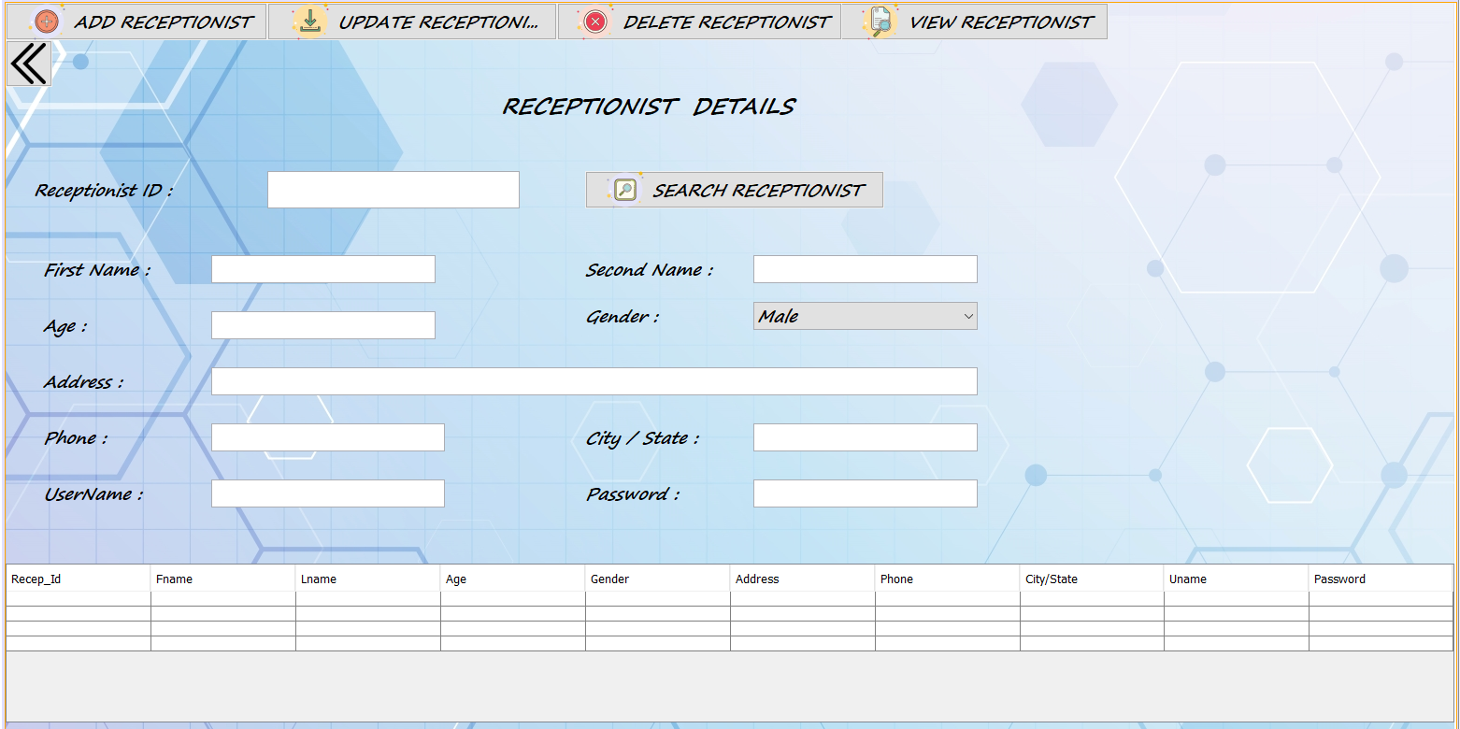

**10.PATIENT DETAILS**

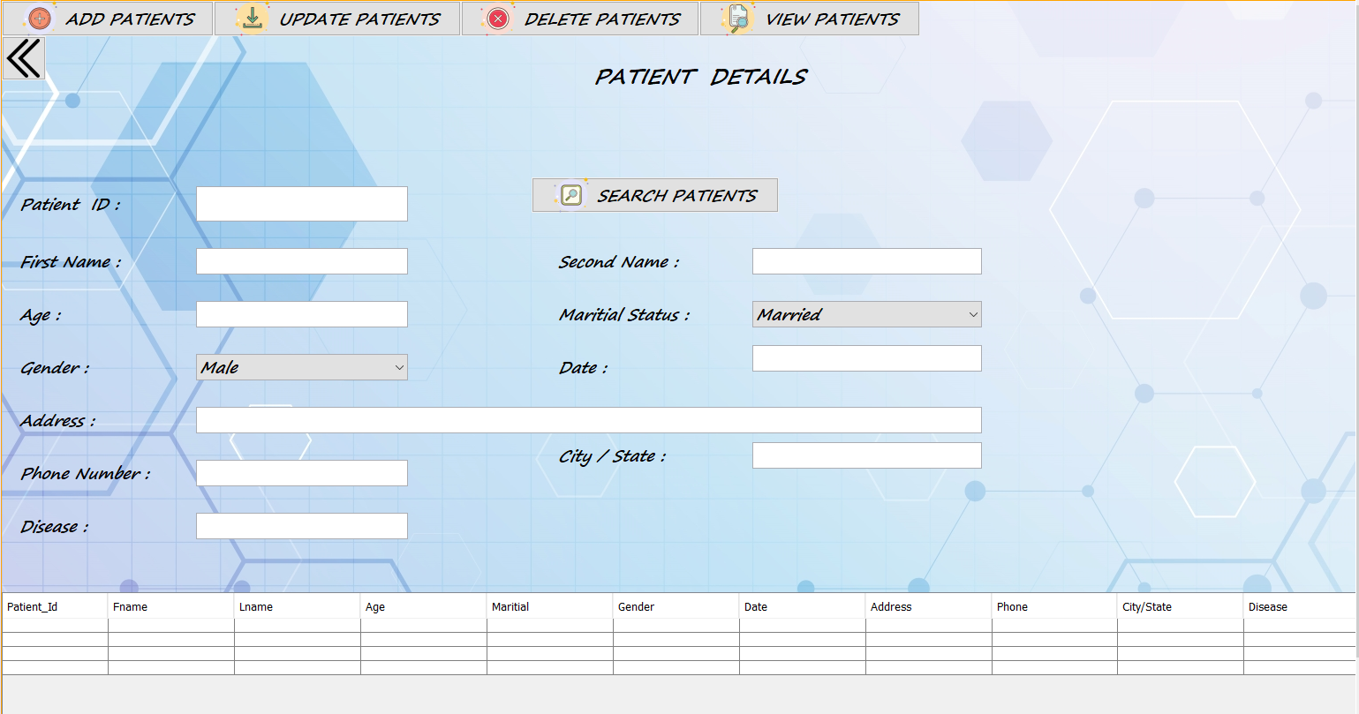

**11.BED DETAILS**

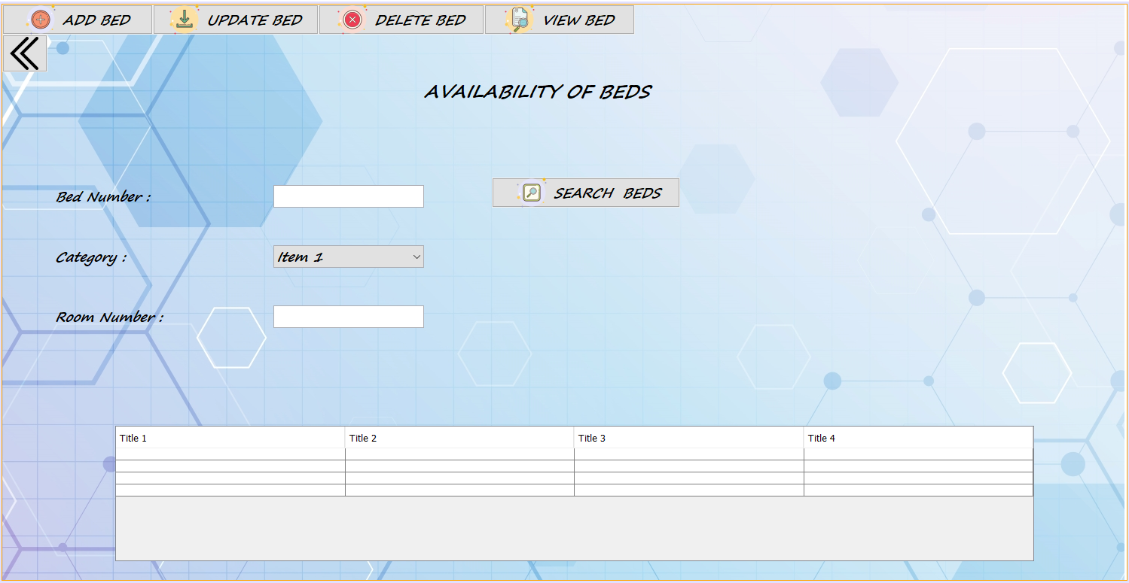

**12.DEPARTMENT DETAILS**

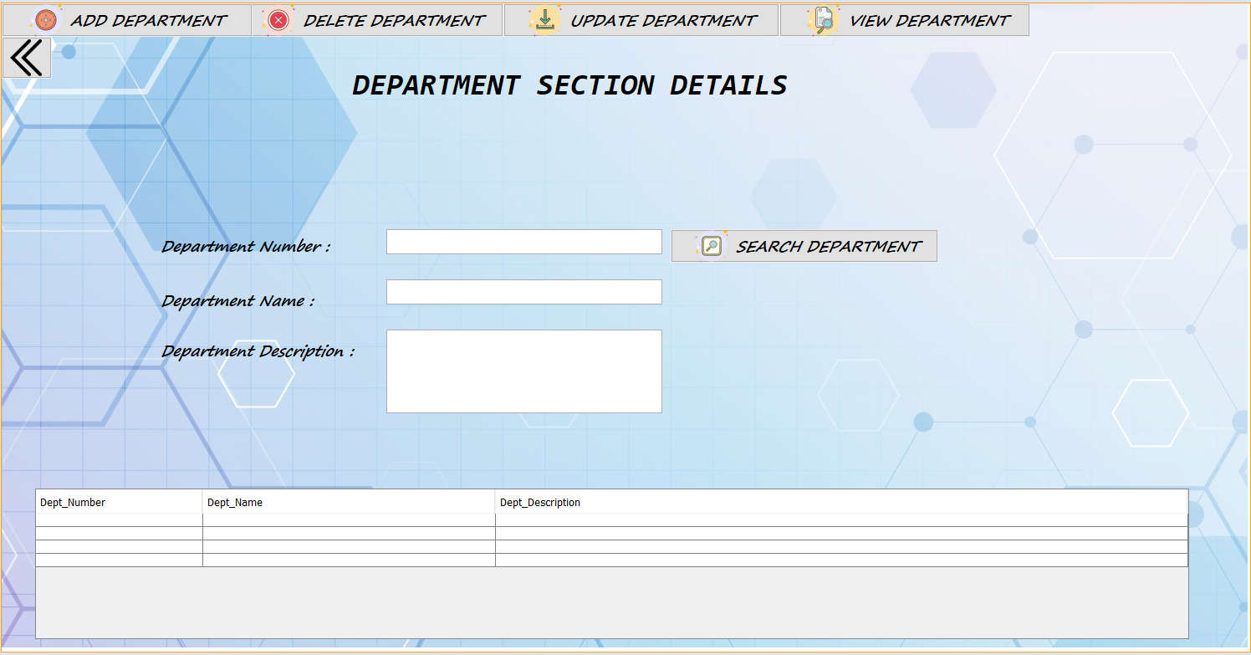

**13.RECEPTIONIST PANEL**

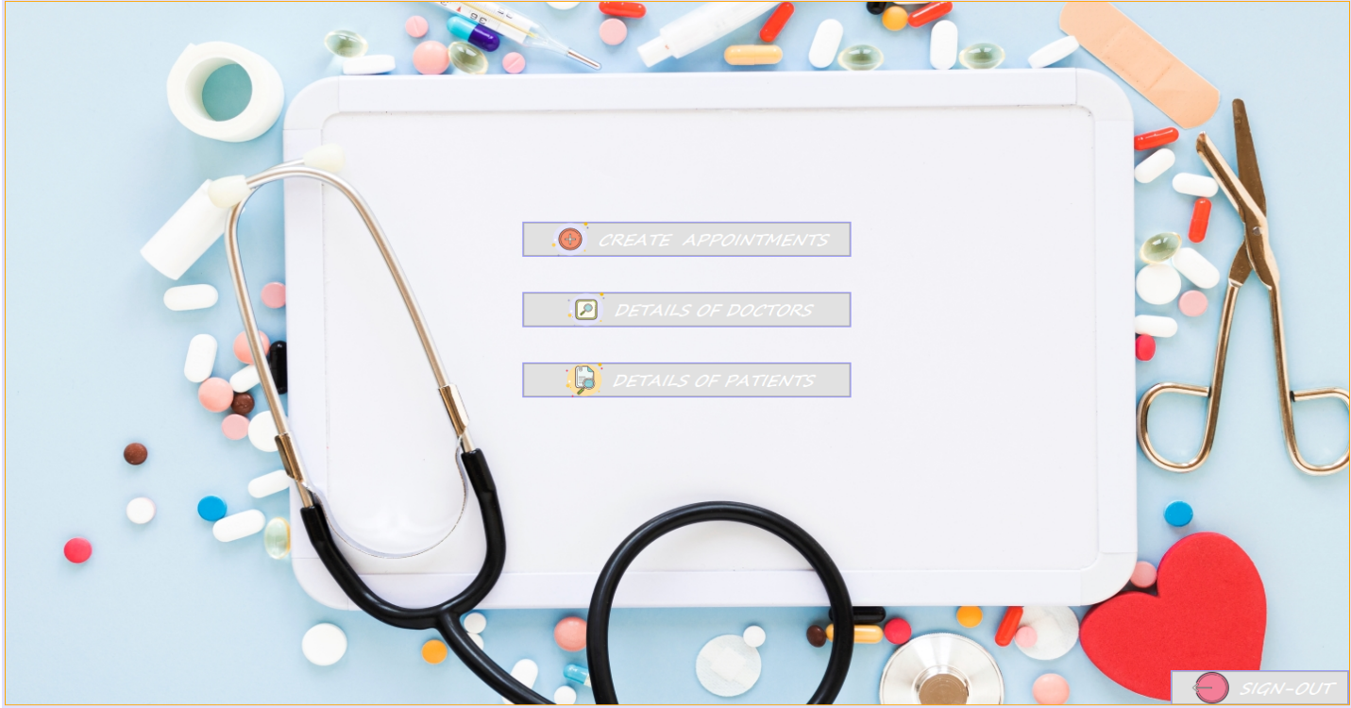

**14.CREATING APPOINTMENTS**

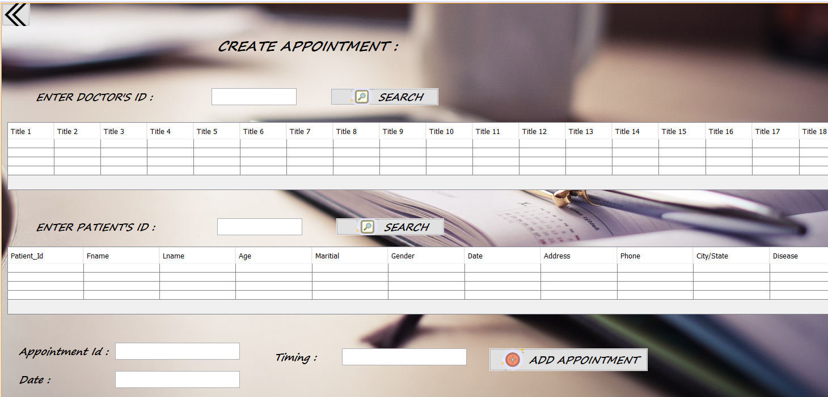

**15.DOCTOR PANEL**

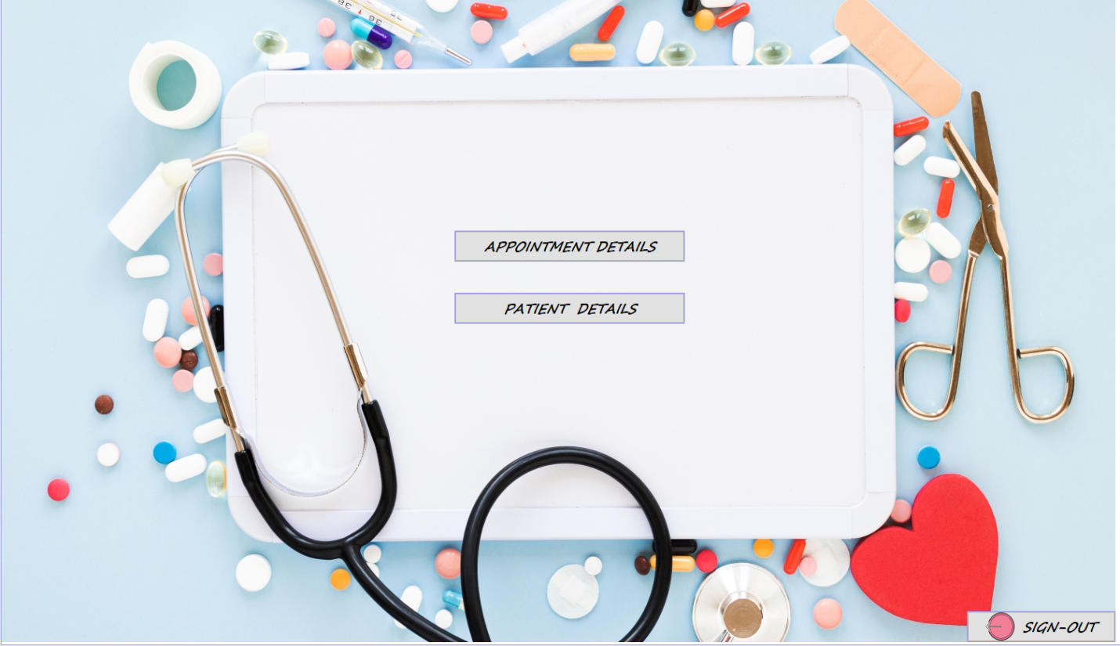

**16.VIEW APPOINTMENTS**

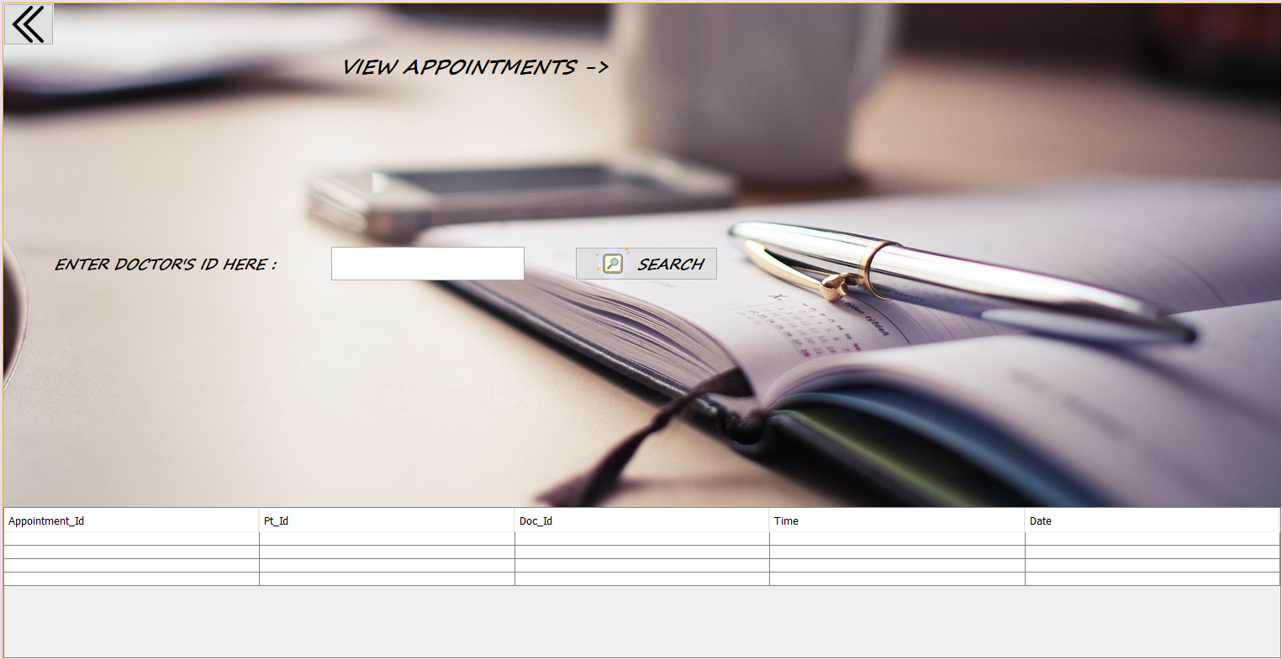

**17.PATIENTS PORTAL**



**18.UPDATE PATIENTS**

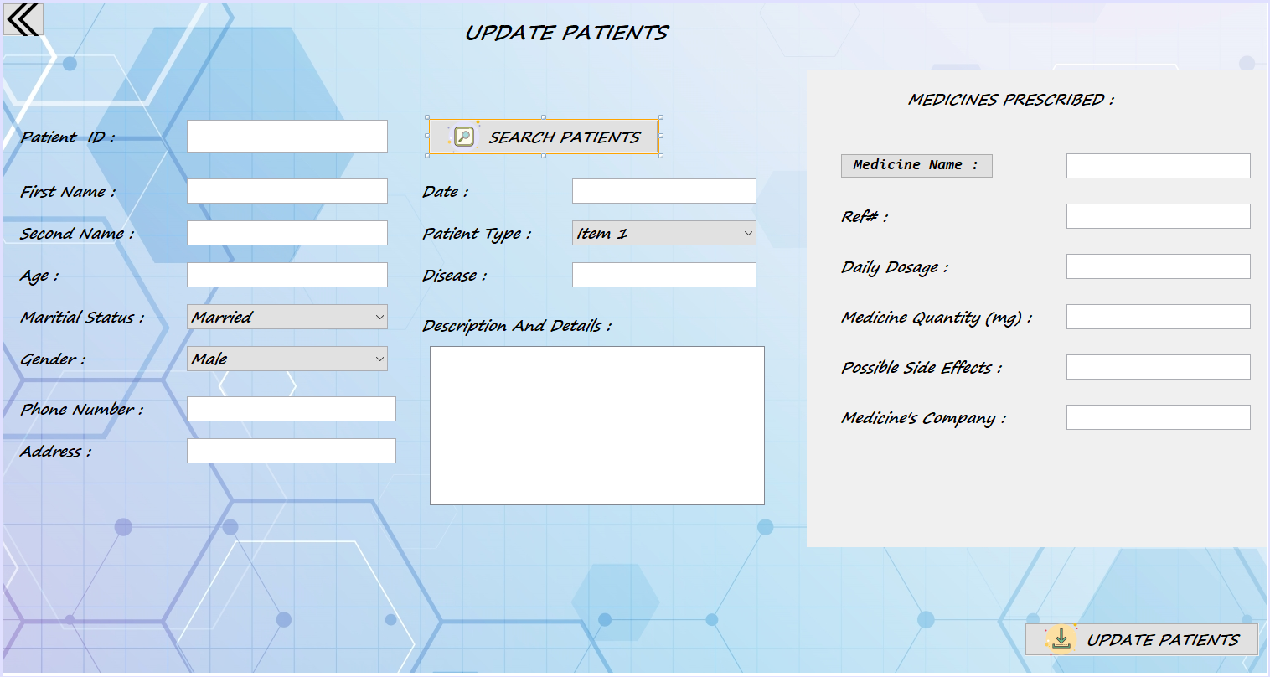

**19.PATIENT’S HISTORY**

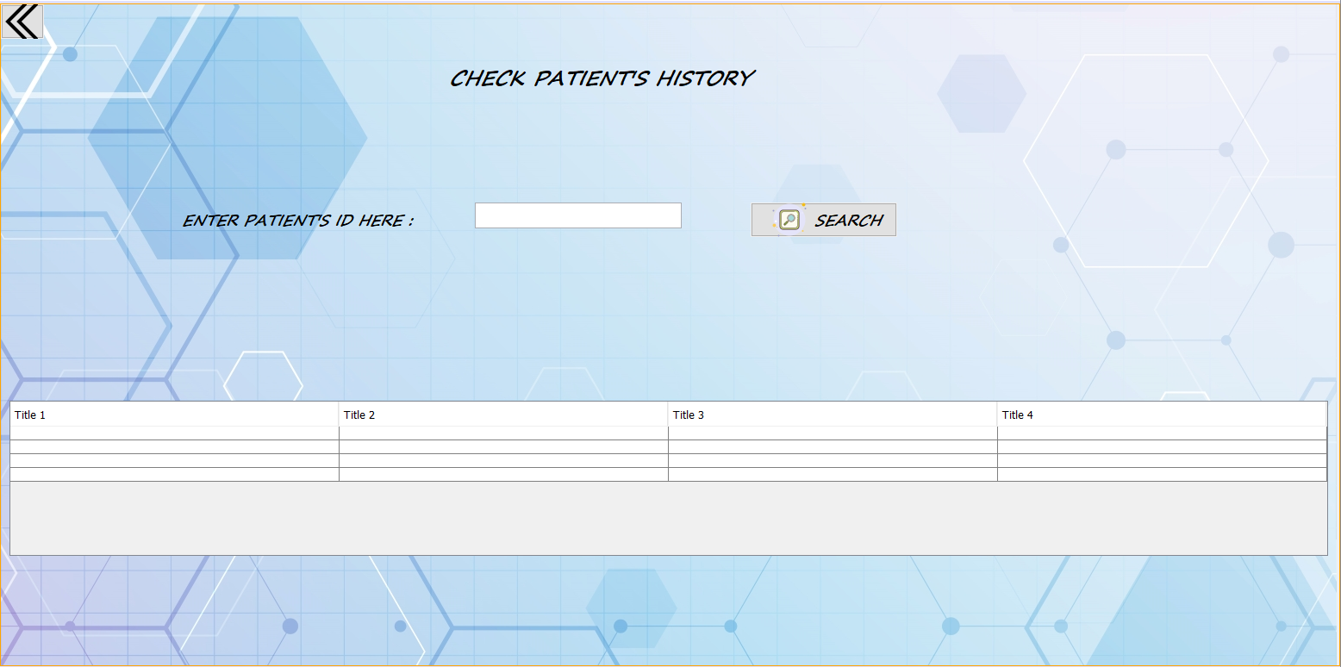

**20.MEDICINE DETAILS(1)**

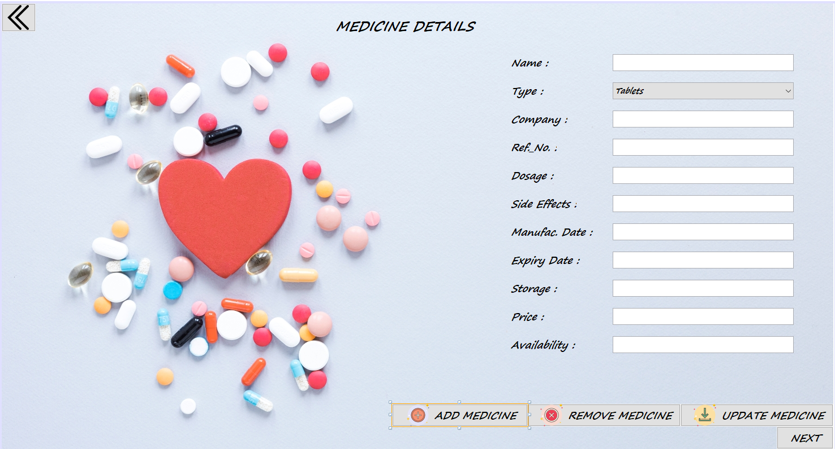

**21.MEDICINE DETAILS(2)**

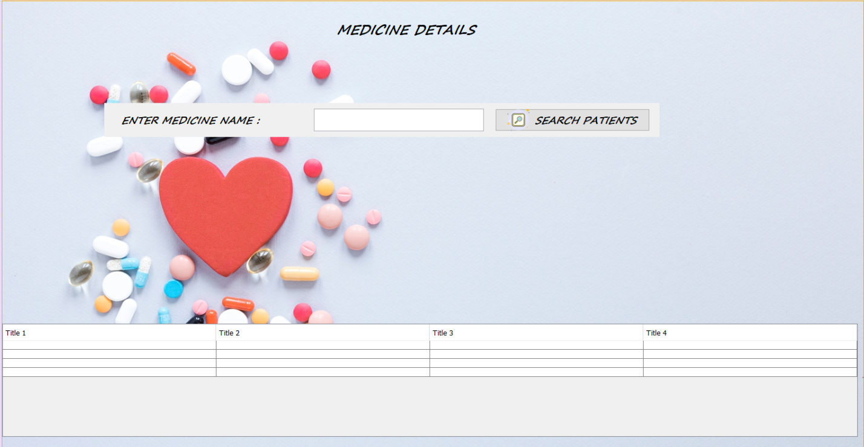

**22.BILLS (1)**

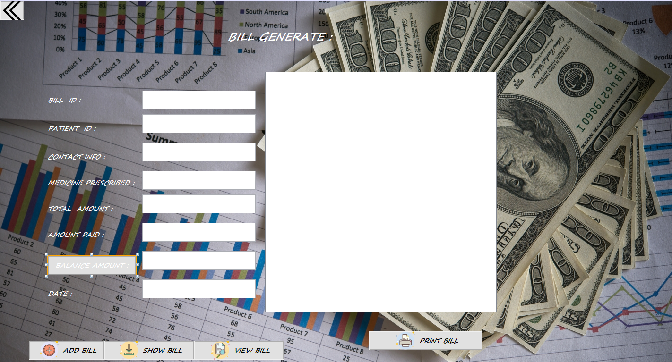

**23.BILLS (2)**

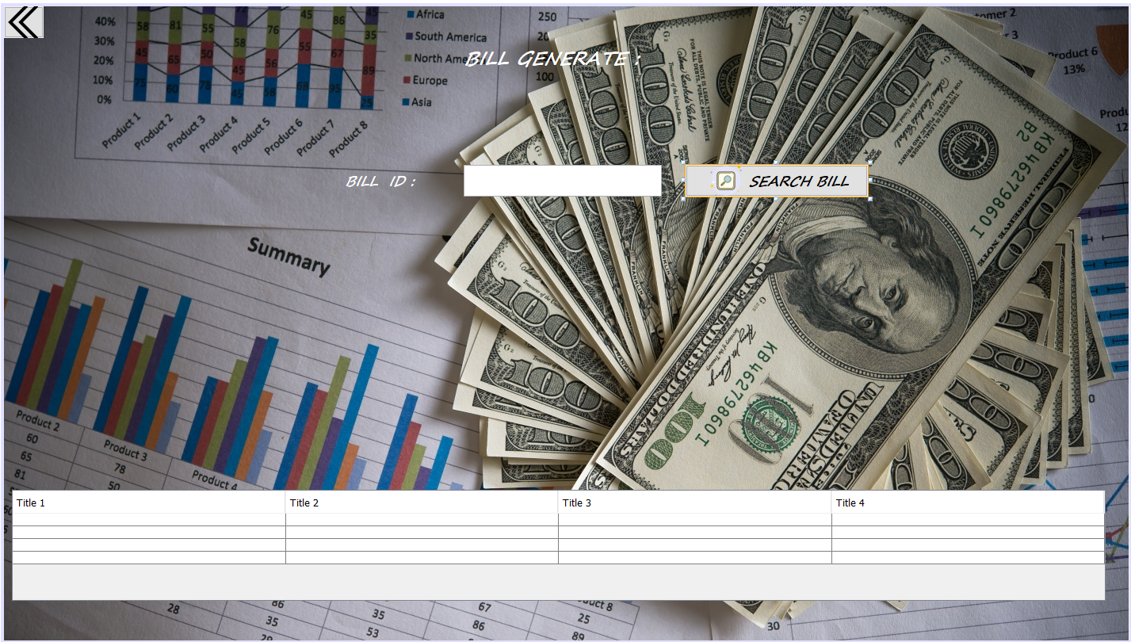

**SOURCE CODE**

1. **SPLASH**

public static void main(String args[]) {

Splash sp=new Splash();

java.awt.EventQueue.invokeLater(new Runnable() {

public void run() {

sp.setVisible(true);

}

});

Index in=new Index();

try{

for(int i=0;i<=100;i++){

Thread.sleep(40);

sp.jProgressBar1.setValue(i);

sp.jLabel1.setText(Integer.toString(i)+"%");

if(i==100){

sp.setVisible(false);

in.setVisible(true);

}

}

}

catch(Exception e){

}

}

1. **INDEX**

private void jButton1ActionPerformed(java.awt.event.ActionEvent evt) {

Admin_Login al= new Admin_Login();

al.setVisible(true);

this.dispose();

}

private void jButton2ActionPerformed(java.awt.event.ActionEvent evt) {

Recep_Login rl= new Recep_Login();

rl.setVisible(true);

this.dispose();

}

private void jButton5ActionPerformed(java.awt.event.ActionEvent evt) {

Doctor_Login doc= new Doctor_Login();

doc.setVisible(true);

this.dispose();

}

private void jButton4ActionPerformed(java.awt.event.ActionEvent evt) {

Pharmacy ph= new Pharmacy();

ph.setVisible(true);

this.dispose();

}

private void jButton3ActionPerformed(java.awt.event.ActionEvent evt) {

System.exit(0);

}

1. **ADMIN LOGIN**

private void jButton2ActionPerformed(java.awt.event.ActionEvent evt) {

jTextField1.setText(null);

jPasswordField1.setText(null);

}

private void jButton1ActionPerformed(java.awt.event.ActionEvent evt) {

String password= jPasswordField1.getText();

String username=jTextField1.getText();

AdminPanel a=new AdminPanel();

if (password.equals("admin") && (username.equals("admin"))){

this.dispose();

a.setVisible(true);

}

else{

JOptionPane.showMessageDialog(this,"Either Admin Username Or Password is Incorrect");

}

}

private void jButton4ActionPerformed(java.awt.event.ActionEvent evt) {

Index i=new Index();

this.dispose();

i.setVisible(true);

}

private void jButton3ActionPerformed(java.awt.event.ActionEvent evt) {

System.exit(0);

}

1. **RECEPTIONIST LOGIN**

private void jButton1ActionPerformed(java.awt.event.ActionEvent evt) {

String s1=jTextField1.getText();

String s2= jPasswordField1.getText();

Recep_Panel rp=new Recep_Panel();

try

{

DriverManager.registerDriver(new com.mysql.jdbc.Driver());

Connection con=DriverManager.getConnection("jdbc:mysql://localhost:3307/hms?user=root&password=");

Statement st=con.createStatement();

ResultSet rs=st.executeQuery("SELECT Uname, Password FROM receptionist WHERE 1");

while(rs.next()){

if (s1.equals(rs.getString(1)) && (s2.equals(rs.getString(2)))){

this.dispose();

rp.setVisible(true);

}

else{

JOptionPane.showMessageDialog(this,"Either Username Or Password is Incorrect");

}

}

}

catch(SQLException e){

JOptionPane.showMessageDialog(this, e.getMessage());

}

}

private void jButton2ActionPerformed(java.awt.event.ActionEvent evt) {

jTextField1.setText(null);

jPasswordField1.setText(null); }

private void jButton3ActionPerformed(java.awt.event.ActionEvent evt) {

System.exit(0);

}

private void jButton4ActionPerformed(java.awt.event.ActionEvent evt) {

Index i=new Index();

this.dispose();

i.setVisible(true);

}

1. **DOCTOR LOG-IN**

private void jButton1ActionPerformed(java.awt.event.ActionEvent evt) {

String s1=jTextField1.getText();

String s2= jPasswordField1.getText();

DoctorPanel dp=new DoctorPanel();

try

{

DriverManager.registerDriver(new com.mysql.jdbc.Driver());

Connection con=DriverManager.getConnection("jdbc:mysql://localhost:3307/hms?user=root&password=");

Statement st=con.createStatement();

ResultSet rs=st.executeQuery("SELECT `Uname`, `Password` FROM `doctor_details` WHERE 1");

while(rs.next()){

if (s1.equals(rs.getString(1)) && (s2.equals(rs.getString(2)))){

this.dispose();

dp.setVisible(true);

}

else{

JOptionPane.showMessageDialog(this,"Either Username Or Password is Incorrect");

}

}

}

catch(SQLException e){

JOptionPane.showMessageDialog(this, e.getMessage());

}

}

1. **MEDICINES**
2. import java.awt.Font;
3. import java.sql.Connection;
4. import java.sql.DriverManager;
5. import java.sql.ResultSet;
6. import java.sql.SQLException;
7. import java.sql.Statement;
8. import javax.swing.JOptionPane;
9. import javax.swing.table.DefaultTableModel;
10. import javax.swing.table.JTableHeader;
11. /**
12. *
13. * @author HP
14. */
15. public class Pharmacy extends javax.swing.JFrame {
16. /**
17. * Creates new form Pharm_Login
18. */
19. public Pharmacy() {
20. initComponents();
21. }

private void jButton1ActionPerformed(java.awt.event.ActionEvent evt) {

String s1=jTextField1.getText();

String s2=(String) jComboBox1.getSelectedItem();

String s3=jTextField2.getText();

String s4=jTextField3.getText();

String s5=jTextField4.getText();

String s6=jTextField5.getText();

String s7=jTextField6.getText();

String s8=jTextField7.getText();

String s9=jTextField8.getText();

String s10=jTextField9.getText();

String s11=jTextField10.getText();

try

{

DriverManager.registerDriver(new com.mysql.jdbc.Driver());

Connection con=DriverManager.getConnection("jdbc:mysql://localhost:3307/hms?user=root&password=");

Statement st=con.createStatement();

int a=st.executeUpdate("INSERT INTO `pharmacy` VALUES('"+s1+"','"+s2+"','"+s3+"','"+s4+"','"+s5+"','"+s6+"','"+s7+"','"+s8+"','"+s9+"','"+s10+"','"+s11+"')");

if(a==1)

{

JOptionPane.showMessageDialog(this,"Added and Saved Successfully !!!","Added",1);

}

else

{

JOptionPane.showMessageDialog(this,"Not Added and Not Saved!!!","",2);

}

} catch (SQLException e) {

System.out.println(e);

}

}

private void jButton2ActionPerformed(java.awt.event.ActionEvent evt) {

String s1=jTextField1.getText();

String s2=(String) jComboBox1.getSelectedItem();

String s3=jTextField2.getText();

String s4=jTextField3.getText();

String s5=jTextField4.getText();

String s6=jTextField5.getText();

String s7=jTextField6.getText();

String s8=jTextField7.getText();

String s9=jTextField8.getText();

String s10=jTextField9.getText();

String s11=jTextField10.getText();

try

{

DriverManager.registerDriver(new com.mysql.jdbc.Driver());

Connection con=DriverManager.getConnection("jdbc:mysql://localhost:3307/hms?user=root&password=");

Statement st=con.createStatement();

int a=st.executeUpdate("DELETE FROM `pharmacy' WHERE `Name`='"+s1+"'");

if(a==1)

{

JOptionPane.showMessageDialog(this,"Deleted Successfully !!!","Added",1);

}

else

{

JOptionPane.showMessageDialog(this,"Not Deleted!!!","",2);

}

} catch (SQLException e) {

System.out.println(e);

}

}

private void jButton3ActionPerformed(java.awt.event.ActionEvent evt) {

String s1=jTextField1.getText();

String s2=(String) jComboBox1.getSelectedItem();

String s3=jTextField2.getText();

String s4=jTextField3.getText();

String s5=jTextField4.getText();

String s6=jTextField5.getText();

String s7=jTextField6.getText();

String s8=jTextField7.getText();

String s9=jTextField8.getText();

String s10=jTextField9.getText();

String s11=jTextField10.getText();

try

{

DriverManager.registerDriver(new com.mysql.jdbc.Driver());

Connection con=DriverManager.getConnection("jdbc:mysql://localhost:3307/hms?user=root&password=");

Statement st=con.createStatement();

int a=st.executeUpdate("UPDATE `pharmacy` SET `Name`='"+s1+"',`Type`='"+s2+"',`Company`='"+s3+"',`Ref_No`='"+s4+"',`Dosage`='"+s5+"',`SideEffects`='"+s6+"',`MFD`='"+s7+"',`ExpDate`='"+s8+"',`Storage`='"+s9+"',`Price`='"+s10+"',`Availability`='"+s11+"' WHERE `Name`='"+s1+"'");

if(a==1)

{

JOptionPane.showMessageDialog(this,"Updated Successfully !!!","Updated",1);

}

else

{

JOptionPane.showMessageDialog(this,"Not Updated!!!","",2);

}

} catch (SQLException e) {

System.out.println(e);

}

}

private void jButton4ActionPerformed(java.awt.event.ActionEvent evt) {

Pharmacy2 pp=new Pharmacy2();

this.dispose();

pp.setVisible(true);

}

1. **ADMIN PANEL**

private void jButton1ActionPerformed(java.awt.event.ActionEvent evt) {

Doctor_Details dd=new Doctor_Details();

dd.setVisible(true);

this.dispose();

}

private void jButton2ActionPerformed(java.awt.event.ActionEvent evt) {

Staffs s=new Staffs();

s.setVisible(true);

this.setVisible(false);

}

private void jButton3ActionPerformed(java.awt.event.ActionEvent evt) {

ReceptionDetails rd=new ReceptionDetails();

rd.setVisible(true);

this.setVisible(false);

}

private void jButton4ActionPerformed(java.awt.event.ActionEvent evt) {

PatientDetails pd=new PatientDetails();

pd.setVisible(true);

this.dispose();

}

private void jButton5ActionPerformed(java.awt.event.ActionEvent evt) {

Bed b=new Bed();

b.setVisible(true);

this.dispose();

}

private void jButton6ActionPerformed(java.awt.event.ActionEvent evt) {

DeptDetails dd1=new DeptDetails();

dd1.setVisible(true);

this.setVisible(false);

}

private void jButton7ActionPerformed(java.awt.event.ActionEvent evt) {

Index i=new Index();

this.dispose();

i.setVisible(true);

}

1. **DOCTOR DTAILS**

import java.awt.Font;

import java.sql.Connection;

import java.sql.DriverManager;

import java.sql.ResultSet;

import java.sql.SQLException;

import java.sql.Statement;

import javax.swing.JOptionPane;

import javax.swing.RowFilter;

import javax.swing.table.DefaultTableModel;

import javax.swing.table.JTableHeader;

import javax.swing.table.TableRowSorter;

private void jButton4ActionPerformed(java.awt.event.ActionEvent evt) {

String s1=jTextField1.getText();

String s2=jTextField2.getText();

String s3=jTextField3.getText();

String s4=jTextField4.getText();

String s5=(String) jComboBox1.getSelectedItem();

String s6=(String) jComboBox2.getSelectedItem();

String s7=(String) jComboBox3.getSelectedItem();

String s8=jTextField5.getText();

String s9=jTextField6.getText();

String s10=(String) jComboBox4.getSelectedItem();

String s11=jTextField7.getText();

String s12=jTextField8.getText();

String s13=jTextField9.getText();

String s14=(String) jComboBox6.getSelectedItem();

String s15=(String) jComboBox5.getSelectedItem();

String s16=jTextField11.getText();

String s17=jTextField12.getText();

try

{

DriverManager.registerDriver(new com.mysql.jdbc.Driver());

Connection con=DriverManager.getConnection("jdbc:mysql://localhost:3307/hms?user=root&password=");

Statement st=con.createStatement();

int a=st.executeUpdate("UPDATE doctor_details SET `Doc_Id`='"+s1+"',`Fname`='"+s2+"',`Lname`='"+s3+"',`Age`='"+s4+"',`Bloog_Grp`='"+s5+"',`Gender`='"+s6+"',`Department`='"+s7+"',`Address`='"+s8+"',`Phone`='"+s9+"',`Marital`='"+s10+"',`City_State`='"+s11+"',`Joining`='"+s12+"',`Leaving`='"+s13+"',`Visiting_Time`='"+s14+"',`Visiting_Days`='"+s15+"',`Uname`='"+s16+"',`Password`='"+s17+"' WHERE `Doc_Id`='"+s1+"'");

if(a==1)

{

JOptionPane.showMessageDialog(this,"Updated Successfully !!!","Updated",1);

}

else

{

JOptionPane.showMessageDialog(this,"Not Updated!!!","",2);

}

} catch (SQLException e) {

System.out.println(e);

}

doctortable();

}

private void jButton1ActionPerformed(java.awt.event.ActionEvent evt) {

String s1=jTextField1.getText();

String s2=jTextField2.getText();

String s3=jTextField3.getText();

String s4=jTextField4.getText();

String s5=(String) jComboBox1.getSelectedItem();

String s6=(String) jComboBox2.getSelectedItem();

String s7=(String) jComboBox3.getSelectedItem();

String s8=jTextField5.getText();

String s9=jTextField6.getText();

String s10=(String) jComboBox4.getSelectedItem();

String s11=jTextField7.getText();

String s12=jTextField8.getText();

String s13=jTextField9.getText();

String s14=(String) jComboBox6.getSelectedItem();

String s15=(String) jComboBox5.getSelectedItem();

String s16=jTextField11.getText();

String s17=jTextField12.getText();

try

{

DriverManager.registerDriver(new com.mysql.jdbc.Driver());

Connection con=DriverManager.getConnection("jdbc:mysql://localhost:3307/hms?user=root&password=");

Statement st=con.createStatement();

int a=st.executeUpdate("INSERT INTO doctor_details VALUES('"+s1+"','"+s2+"','"+s3+"','"+s4+"','"+s5+"','"+s6+"','"+s7+"','"+s8+"','"+s9+"','"+s10+"','"+s11+"','"+s12+"','"+s13+"','"+s14+"','"+s15+"','"+s16+"','"+s17+"')");

if(a==1)

{

JOptionPane.showMessageDialog(this,"Added and Saved Successfully !!!","Added",1);

}

else

{

JOptionPane.showMessageDialog(this,"Not Added and Not Saved!!!","",2);

}

con.close();

jTextField1.setText(" ");

jTextField2.setText(" ");

jTextField3.setText(" ");

jTextField4.setText(" ");

jComboBox1.setSelectedItem(" ");

jComboBox2.setSelectedItem(" ");

jComboBox3.setSelectedItem(" ");

jTextField5.setText(" ");

jTextField6.setText(" ");

jComboBox4.setSelectedItem(" ");

jTextField7.setText(" ");

jTextField8.setText(" ");

jTextField9.setText(" ");

jComboBox6.setSelectedItem(" ");

jComboBox5.setSelectedItem(" ");

jTextField11.setText(" ");

jTextField12.setText(" ");

} catch (SQLException e) {

System.out.println(e);

}

doctortable();

}

private void jButton5ActionPerformed(java.awt.event.ActionEvent evt) {

String s1=jTextField1.getText();

String s2=jTextField2.getText();

String s3=jTextField3.getText();

String s4=jTextField4.getText();

String s5=(String) jComboBox1.getSelectedItem();

String s6=(String) jComboBox2.getSelectedItem();

String s7=(String) jComboBox3.getSelectedItem();

String s8=jTextField5.getText();

String s9=jTextField6.getText();

String s10=(String) jComboBox4.getSelectedItem();

String s11=jTextField7.getText();

String s12=jTextField8.getText();

String s13=jTextField9.getText();

String s14=(String) jComboBox6.getSelectedItem();

String s15=(String) jComboBox5.getSelectedItem();

String s16=jTextField11.getText();

String s17=jTextField12.getText();

try

{

DriverManager.registerDriver(new com.mysql.jdbc.Driver());

Connection con=DriverManager.getConnection("jdbc:mysql://localhost:3307/hms?user=root&password=");

Statement st=con.createStatement();

int a=st.executeUpdate("SELECT * FROM doctor_details VALUES('"+s1+"','"+s2+"','"+s3+"','"+s4+"','"+s5+"','"+s6+"','"+s7+"','"+s8+"','"+s9+"','"+s10+"','"+s11+"','"+s12+"','"+s13+"','"+s14+"','"+s15+"','"+s16+"','"+s17+"')WHERE 1");

if(a==1)

{

JOptionPane.showMessageDialog(this,"Viewed Successfully !!!","Added",1);

}

else

{

JOptionPane.showMessageDialog(this,"Not Viewed!!!","",2);

}

} catch (SQLException e) {

System.out.println(e);

}

doctortable();

}

private void jButton7ActionPerformed(java.awt.event.ActionEvent evt) {

AdminPanel ap=new AdminPanel();

this.dispose();

ap.setVisible(true);

}

public void doctortable()

{

try{

Font f=new Font("Consolas",Font.BOLD,12);

JTableHeader header=jTable1.getTableHeader();

header.setFont(f);

DriverManager.registerDriver(new com.mysql.jdbc.Driver());

Connection con=DriverManager.getConnection("jdbc:mysql://localhost:3307/hms?user=root&password=");

Statement st=con.createStatement();

ResultSet rs=st.executeQuery("SELECT * FROM doctor_details");

while(jTable1.getRowCount()>0)

{

((DefaultTableModel) jTable1.getModel()).removeRow(0);

}

int column=rs.getMetaData().getColumnCount();

while(rs.next())

{

Object[] row=new Object[column];

for(int i=1;i<=column;i++)

{

row[i-1]=rs.getObject(i);

}

((DefaultTableModel) jTable1.getModel()).insertRow(rs.getRow()-1, row);

}

rs.close();

con.close();

}

catch(SQLException e){

JOptionPane.showMessageDialog(this,"error!!!"+e);

}

}

1. **PATIENT DETAILS**

private void jButton1ActionPerformed(java.awt.event.ActionEvent evt) {

String s1=jTextField1.getText();

String s2=jTextField2.getText();

String s3=jTextField3.getText();

String s4=jTextField4.getText();

String s5=(String) jComboBox1.getSelectedItem();

String s6=(String) jComboBox2.getSelectedItem();

String s7=jTextField5.getText();

String s8=jTextField6.getText();

String s9=jTextField7.getText();

String s10=jTextField8.getText();

String s11=jTextField9.getText();

try

{

DriverManager.registerDriver(new com.mysql.jdbc.Driver());

Connection con=DriverManager.getConnection("jdbc:mysql://localhost:3307/hms?user=root&password=");

Statement st=con.createStatement();

int a=st.executeUpdate("INSERT INTO patientdetails VALUES('"+s1+"','"+s2+"','"+s3+"','"+s4+"','"+s5+"','"+s6+"','"+s7+"','"+s8+"','"+s9+"','"+s10+"','"+s11+"')");

if(a==1)

{

JOptionPane.showMessageDialog(this,"Added and Saved Successfully !!!","Added",1);

}

else

{

JOptionPane.showMessageDialog(this,"Not Added and Not Saved!!!","",2);

}

} catch (SQLException e) {

System.out.println(e);

}

patienttable(); }

private void jButton2ActionPerformed(java.awt.event.ActionEvent evt) {

String s1=jTextField1.getText();

String s2=jTextField2.getText();

String s3=jTextField3.getText();

String s4=jTextField4.getText();

String s5=(String) jComboBox1.getSelectedItem();

String s6=(String) jComboBox2.getSelectedItem();

String s7=jTextField5.getText();

String s8=jTextField6.getText();

String s9=jTextField7.getText();

String s10=jTextField8.getText();

String s11=jTextField9.getText();

try

{

DriverManager.registerDriver(new com.mysql.jdbc.Driver());

Connection con=DriverManager.getConnection("jdbc:mysql://localhost:3307/hms?user=root&password=");

Statement st=con.createStatement();

int a=st.executeUpdate("UPDATE `patientdetails` SET `Pt_Id`='"+s1+"',`Fname`='"+s2+"',`Lname`='"+s3+"',`Age`='"+s4+"',`Maritial`='"+s5+"',`Gender`='"+s6+"',`Date`='"+s7+"',`Address`='"+s8+"',`Phone`='"+9+"',`City_State`='"+s10+"',`Disease`='"+s11+"' WHERE `Pt_Id`='"+s1+"'");

if(a==1)

{

JOptionPane.showMessageDialog(this,"Updated Successfully !!!","Updated",1);

}

else

{

JOptionPane.showMessageDialog(this,"Not Updated!!!","",2);

}

} catch (SQLException e) {

System.out.println(e);

}

patienttable();

}

private void jButton3ActionPerformed(java.awt.event.ActionEvent evt) {

String s1=jTextField1.getText();

String s2=jTextField2.getText();

String s3=jTextField3.getText();

String s4=jTextField4.getText();

String s5=(String) jComboBox1.getSelectedItem();

String s6=(String) jComboBox2.getSelectedItem();

String s7=jTextField5.getText();

String s8=jTextField6.getText();

String s9=jTextField7.getText();

String s10=jTextField8.getText();

String s11=jTextField9.getText();

try

{

DriverManager.registerDriver(new com.mysql.jdbc.Driver());

Connection con=DriverManager.getConnection("jdbc:mysql://localhost:3307/hms?user=root&password=");

Statement st=con.createStatement();

int a=st.executeUpdate("DELETE FROM patientdetails WHERE `Pt_Id`='"+s1+"'");

if(a==1)

{

JOptionPane.showMessageDialog(this,"Deleted Successfully !!!","Added",1);

}

else

{

JOptionPane.showMessageDialog(this,"Not Deleted!!!","",2);

}

} catch (SQLException e) {

System.out.println(e);

}

patienttable();

}

private void jButton6ActionPerformed(java.awt.event.ActionEvent evt) {

String s1=jTextField1.getText();

try{

DriverManager.registerDriver(new com.mysql.jdbc.Driver());

Connection con=DriverManager.getConnection("jdbc:mysql://localhost:3307/hms?user=root&password=");

Statement st=con.createStatement();

ResultSet rs=st.executeQuery("SELECT * FROM patientdetails WHERE Pt_Id='"+s1+"'");

while(rs.next()){

jTextField2.setText(rs.getString(2));

jTextField3.setText(rs.getString(3));

jTextField4.setText(rs.getString(4));

jComboBox1.setSelectedItem(rs.getString(5));

jComboBox2.setSelectedItem(rs.getString(6));

jTextField5.setText(rs.getString(7));

jTextField6.setText(rs.getString(8));

jTextField7.setText(rs.getString(9));

jTextField8.setText(rs.getString(10));

jTextField9.setText(rs.getString(11));

DefaultTableModel model;

model=(DefaultTableModel)jTable1.getModel();

TableRowSorter<DefaultTableModel>tr= new TableRowSorter<DefaultTableModel>(model);

jTable1.setRowSorter(tr);

tr.setRowFilter(RowFilter.regexFilter(jTextField1.getText().trim()));

}

}catch(SQLException e){

System.out.println(e);

}

patienttable();

}

public void patienttable()

{

try{

Font f=new Font("Consolas",Font.BOLD,12);

JTableHeader header=jTable1.getTableHeader();

header.setFont(f);

DriverManager.registerDriver(new com.mysql.jdbc.Driver());

Connection con=DriverManager.getConnection("jdbc:mysql://localhost:3307/hms?user=root&password=");

Statement st=con.createStatement();

ResultSet rs=st.executeQuery("SELECT * FROM patientdetails");

while(jTable1.getRowCount()>0)

{

((DefaultTableModel) jTable1.getModel()).removeRow(0);

}

int column=rs.getMetaData().getColumnCount();

while(rs.next())

{

Object[] row=new Object[column];

for(int i=1;i<=column;i++)

{

row[i-1]=rs.getObject(i);

}

((DefaultTableModel) jTable1.getModel()).insertRow(rs.getRow()-1, row);

}

rs.close();

con.close();

}

catch(SQLException e){

JOptionPane.showMessageDialog(this,"error!!!"+e);

}

}

1. **STAFF DETAILS**

private void jButton2ActionPerformed(java.awt.event.ActionEvent evt) {

String s1=jTextField1.getText();

String s2=jTextField2.getText();

String s3=jTextField3.getText();

String s4=jTextField4.getText();

String s5=(String) jComboBox1.getSelectedItem();

String s6=jTextField5.getText();

String s7=jTextField6.getText();

String s8=jTextField7.getText();

String s9=jTextField8.getText();

String s10=(String) jComboBox2.getSelectedItem();

String s11=jTextField9.getText();

try

{

DriverManager.registerDriver(new com.mysql.jdbc.Driver());

Connection con=DriverManager.getConnection("jdbc:mysql://localhost:3307/hms?user=root&password=");

Statement st=con.createStatement();

int a=st.executeUpdate("INSERT INTO Staffs VALUES('"+s1+"','"+s2+"','"+s3+"','"+s4+"','"+s5+"','"+s6+"','"+s7+"','"+s8+"','"+s9+"','"+s10+"','"+s11+"')");

if(a==1)

{

JOptionPane.showMessageDialog(this,"Added and Saved Successfully !!!","Added",1);

}

else

{

JOptionPane.showMessageDialog(this,"Not Added and Not Saved!!!","",2);

}

} catch (SQLException e) {

System.out.println(e);

}

stafftable();

}

private void jButton3ActionPerformed(java.awt.event.ActionEvent evt) {

String s1=jTextField1.getText();

String s2=jTextField2.getText();

String s3=jTextField3.getText();

String s4=jTextField4.getText();

String s5=(String) jComboBox1.getSelectedItem();

String s6=jTextField5.getText();

String s7=jTextField6.getText();

String s8=jTextField7.getText();

String s9=jTextField8.getText();

String s10=(String) jComboBox2.getSelectedItem();

String s11=jTextField9.getText();

try

{

DriverManager.registerDriver(new com.mysql.jdbc.Driver());

Connection con=DriverManager.getConnection("jdbc:mysql://localhost:3307/hms?user=root&password=");

Statement st=con.createStatement();

int a=st.executeUpdate("UPDATE `staffs` SET `Staff_Id`='"+s1+"',`Fname`='"+s2+"',`Lname`='"+s3+"',`Age`='"+s4+"',`Gender`='"+s5+"',`Address`='"+s6+"',`City_State`='"+s7+"',`Phone`='"+s8+"',`Joining`='"+s9+"',`Staff_Type`='"+s10+"',`Leaving`='"+s11+"' WHERE `Staff_Id`='"+s1+"'");

if(a==1)

{

JOptionPane.showMessageDialog(this,"Updated Successfully !!!","updated",1);

}

else

{

JOptionPane.showMessageDialog(this,"Not Updated !!!","",2);

}

} catch (SQLException e) {

System.out.println(e);

}

stafftable();

}

private void jButton4ActionPerformed(java.awt.event.ActionEvent evt) {

String s1=jTextField1.getText();

String s2=jTextField2.getText();

String s3=jTextField3.getText();

String s4=jTextField4.getText();

String s5=(String) jComboBox1.getSelectedItem();

String s6=jTextField5.getText();

String s7=jTextField6.getText();

String s8=jTextField7.getText();

String s9=jTextField8.getText();

String s10=(String) jComboBox2.getSelectedItem();

String s11=jTextField9.getText();

try

{

DriverManager.registerDriver(new com.mysql.jdbc.Driver());

Connection con=DriverManager.getConnection("jdbc:mysql://localhost:3307/hms?user=root&password=");

Statement st=con.createStatement();

int a=st.executeUpdate("DELETE FROM staffs WHERE `Staff_Id`='"+s1+"'");

if(a==1)

{

JOptionPane.showMessageDialog(this,"Deleted Successfully !!!","Deleted",1);

}

else

{

JOptionPane.showMessageDialog(this,"Not Deleted !!!","",2);

}

} catch (SQLException e) {

System.out.println(e);

}

stafftable();

}

private void jButton1ActionPerformed(java.awt.event.ActionEvent evt) {

String s1=jTextField1.getText();

String s2=jTextField2.getText();

String s3=jTextField3.getText();

String s4=jTextField4.getText();

String s5=(String) jComboBox1.getSelectedItem();

String s6=jTextField5.getText();

String s7=jTextField6.getText();

String s8=jTextField7.getText();

String s9=jTextField8.getText();

String s10=(String) jComboBox2.getSelectedItem();

String s11=jTextField9.getText();

try

{

DriverManager.registerDriver(new com.mysql.jdbc.Driver());

Connection con=DriverManager.getConnection("jdbc:mysql://localhost:3307/hms?user=root&password=");

Statement st=con.createStatement();

ResultSet rs=st.executeQuery("SELECT * FROM staffs WHERE `Staff_Id`='"+s1+"'");

while(rs.next()){

jTextField2.setText(rs.getString(2));

jTextField2.setText(rs.getString(3));

jTextField4.setText(rs.getString(4));

jComboBox1.setSelectedItem(rs.getString(5));

jTextField5.setText(rs.getString(6));

jTextField6.setText(rs.getString(7));

jTextField7.setText(rs.getString(8));

jTextField8.setText(rs.getString(9));

jComboBox2.setSelectedItem(rs.getString(10));

jTextField9.setText(rs.getString(11));

DefaultTableModel model;

model=(DefaultTableModel)jTable1.getModel();

TableRowSorter<DefaultTableModel>tr= new TableRowSorter<DefaultTableModel>(model);

jTable1.setRowSorter(tr);

tr.setRowFilter(RowFilter.regexFilter(jTextField1.getText().trim()));

}

}

catch(SQLException e){

System.out.println(e);

}

stafftable();

}

public void stafftable()

{

try{

Font f=new Font("Consolas",Font.BOLD,12);

JTableHeader header=jTable1.getTableHeader();

header.setFont(f);

DriverManager.registerDriver(new com.mysql.jdbc.Driver());

Connection con=DriverManager.getConnection("jdbc:mysql://localhost:3307/hms?user=root&password=");

Statement st=con.createStatement();

ResultSet rs=st.executeQuery("SELECT * FROM staffs");

while(jTable1.getRowCount()>0)

{

((DefaultTableModel) jTable1.getModel()).removeRow(0);

}

int column=rs.getMetaData().getColumnCount();

while(rs.next())

{

Object[] row=new Object[column];

for(int i=1;i<=column;i++)

{

row[i-1]=rs.getObject(i);

}

((DefaultTableModel) jTable1.getModel()).insertRow(rs.getRow()-1, row);

}

rs.close();

con.close();

}

catch(SQLException e){

JOptionPane.showMessageDialog(this,"error!!!"+e);

}

}

1. **RECEPTIONIST DETAILS**

private void jButton3ActionPerformed(java.awt.event.ActionEvent evt) {

String s1=jTextField9.getText();

String s2=jTextField1.getText();

String s3=jTextField2.getText();

String s4=jTextField3.getText();

String s5=(String) jComboBox1.getSelectedItem();

String s6=jTextField4.getText();

String s7=jTextField5.getText();

String s8=jTextField6.getText();

String s9=jTextField7.getText();

String s10=jTextField8.getText();

try

{

DriverManager.registerDriver(new com.mysql.jdbc.Driver());

Connection con=DriverManager.getConnection("jdbc:mysql://localhost:3307/hms?user=root&password=");

Statement st=con.createStatement();

int a=st.executeUpdate("DELETE FROM `receptionist` WHERE `Receptionist_Id`='"+s1+"'");

if(a==1)

{

JOptionPane.showMessageDialog(this,"Deleted Successfully !!!","Added",1);

}

else

{

JOptionPane.showMessageDialog(this,"Not Deleted!!!","",2);

}

} catch (SQLException e) {

System.out.println(e);

}

receptable();

}

private void jButton2ActionPerformed(java.awt.event.ActionEvent evt) {

String s1=jTextField9.getText();

String s2=jTextField1.getText();

String s3=jTextField2.getText();

String s4=jTextField3.getText();

String s5=(String) jComboBox1.getSelectedItem();

String s6=jTextField4.getText();

String s7=jTextField5.getText();

String s8=jTextField6.getText();

String s9=jTextField7.getText();

String s10=jTextField8.getText();

try

{

DriverManager.registerDriver(new com.mysql.jdbc.Driver());

Connection con=DriverManager.getConnection("jdbc:mysql://localhost:3307/hms?user=root&password=");

Statement st=con.createStatement();

int a=st.executeUpdate("UPDATE `receptionist` SET `Receptionist_Id`='"+s1+"',`Fname`='"+s1+"',`Lname`='"+s1+"',`Age`='"+s1+"',`Gender`='"+s1+"',`Address`='"+s1+"',`Phone`='"+s1+"',`City_State`='"+s1+"',`Uname`='"+s1+"',`Password`='"+s1+"' WHERE `Receptionist_Id`='"+s1+"'");

if(a==1)

{

JOptionPane.showMessageDialog(this,"Updated Successfully !!!","Updated",1);

}

else

{

JOptionPane.showMessageDialog(this,"Not Updated!!!","",2);

}

} catch (SQLException e) {

System.out.println(e);

}

receptable();

}

private void jButton1ActionPerformed(java.awt.event.ActionEvent evt) {

String s1=jTextField9.getText();

String s2=jTextField1.getText();

String s3=jTextField2.getText();

String s4=jTextField3.getText();

String s5=(String) jComboBox1.getSelectedItem();

String s6=jTextField4.getText();

String s7=jTextField5.getText();

String s8=jTextField6.getText();

String s9=jTextField7.getText();

String s10=jTextField8.getText();

try

{

DriverManager.registerDriver(new com.mysql.jdbc.Driver());

Connection con=DriverManager.getConnection("jdbc:mysql://localhost:3307/hms?user=root&password=");

Statement st=con.createStatement();

int a=st.executeUpdate("INSERT INTO `receptionist` VALUES('"+s1+"','"+s2+"','"+s3+"','"+s4+"','"+s5+"','"+s6+"','"+s7+"','"+s8+"','"+s9+"','"+s10+"')");

if(a==1)

{

JOptionPane.showMessageDialog(this,"Added and Saved Successfully !!!","Added",1);

}

else

{

JOptionPane.showMessageDialog(this,"Not Added and Not Saved!!!","",2);

}

} catch (SQLException e) {

System.out.println(e);

}

receptable();

}

private void jButton6ActionPerformed(java.awt.event.ActionEvent evt) {

AdminPanel ap=new AdminPanel();

this.dispose();

ap.setVisible(true);

}

private void jButton5ActionPerformed(java.awt.event.ActionEvent evt) {

String s1=jTextField9.getText();

try{

DriverManager.registerDriver(new com.mysql.jdbc.Driver());

Connection con=DriverManager.getConnection("jdbc:mysql://localhost:3307/hms?user=root&password=");

Statement st=con.createStatement();

ResultSet rs=st.executeQuery("SELECT * FROM receptionist WHERE Receptionist_Id='"+s1+"'");

while(rs.next()){

DefaultTableModel model;

model=(DefaultTableModel)jTable1.getModel();

TableRowSorter<DefaultTableModel>tr= new TableRowSorter<DefaultTableModel>(model);

jTable1.setRowSorter(tr);

tr.setRowFilter(RowFilter.regexFilter(jTextField9.getText().trim()));

}

} catch(SQLException e){

System.out.println(e);

}

receptable();

}

public void receptable()

{

try{

Font f=new Font("Consolas",Font.BOLD,12);

JTableHeader header=jTable1.getTableHeader();

header.setFont(f);

DriverManager.registerDriver(new com.mysql.jdbc.Driver());

Connection con=DriverManager.getConnection("jdbc:mysql://localhost:3307/hms?user=root&password=");

Statement st=con.createStatement();

ResultSet rs=st.executeQuery("SELECT * FROM staffs");

while(jTable1.getRowCount()>0)

{

((DefaultTableModel) jTable1.getModel()).removeRow(0);

}

int column=rs.getMetaData().getColumnCount();

while(rs.next())

{

Object[] row=new Object[column];

for(int i=1;i<=column;i++)

{

row[i-1]=rs.getObject(i);

}

((DefaultTableModel) jTable1.getModel()).insertRow(rs.getRow()-1, row);

}

rs.close();

con.close();

}

catch(SQLException e){

JOptionPane.showMessageDialog(this,"error!!!"+e);

}

}

1. **BEDS AVAILABLITY**

private void jButton1ActionPerformed(java.awt.event.ActionEvent evt) {

String s1=jTextField1.getText();

String s2=(String) jComboBox1.getSelectedItem();

String s3=jTextField2.getText();

try

{

DriverManager.registerDriver(new com.mysql.jdbc.Driver());

Connection con=DriverManager.getConnection("jdbc:mysql://localhost:3307/hms?user=root&password=");

Statement st=con.createStatement();

int a=st.executeUpdate("INSERT INTO patientdetails VALUES('"+s1+"','"+s2+"','"+s3+"')");

if(a==1)

{

JOptionPane.showMessageDialog(this,"Added and Saved Successfully !!!","Added",1);

}

else

{

JOptionPane.showMessageDialog(this,"Not Added and Not Saved!!!","",2);

}

} catch (SQLException e) {

System.out.println(e);

}

bedtable();

}

private void jButton2ActionPerformed(java.awt.event.ActionEvent evt) {

String s1=jTextField1.getText();

String s2=(String) jComboBox1.getSelectedItem();

String s3=jTextField2.getText();

try

{

DriverManager.registerDriver(new com.mysql.jdbc.Driver());

Connection con=DriverManager.getConnection("jdbc:mysql://localhost:3307/hms?user=root&password=");

Statement st=con.createStatement();

int a=st.executeUpdate("UPDATE `bed` SET `Bed_Number`='"+s1+"',`Category`='"+s2+"',`Room_No`='"+s3+"' WHERE `Bed_Number`='"+s1+"'");

if(a==1)

{

JOptionPane.showMessageDialog(this,"Updated Successfully !!!","Updated",1);

}

else

{

JOptionPane.showMessageDialog(this,"Not Updated!!!","",2);

}

} catch (SQLException e) {

System.out.println(e);

}

bedtable();

}

private void jButton3ActionPerformed(java.awt.event.ActionEvent evt) {

String s1=jTextField1.getText();

String s2=(String) jComboBox1.getSelectedItem();

String s3=jTextField2.getText();

try

{

DriverManager.registerDriver(new com.mysql.jdbc.Driver());

Connection con=DriverManager.getConnection("jdbc:mysql://localhost:3307/hms?user=root&password=");

Statement st=con.createStatement();

int a=st.executeUpdate("DELETE FROM bed WHERE `Bed_Number`='"+s1+"'");

if(a==1)

{

JOptionPane.showMessageDialog(this,"Deleted Successfully !!!","Added",1);

}

else

{

JOptionPane.showMessageDialog(this,"Not Deleted!!!","",2);

}

} catch (SQLException e) {

System.out.println(e);

}

bedtable();

}

private void jButton4ActionPerformed(java.awt.event.ActionEvent evt) {

}

private void jButton5ActionPerformed(java.awt.event.ActionEvent evt) {

AdminPanel ap=new AdminPanel();

this.dispose();

ap.setVisible(true);

}

private void jButton6ActionPerformed(java.awt.event.ActionEvent evt) {

String s1=jTextField1.getText();

String s2=(String) jComboBox1.getSelectedItem();

String s3=jTextField2.getText();

try

{

DriverManager.registerDriver(new com.mysql.jdbc.Driver());

Connection con=DriverManager.getConnection("jdbc:mysql://localhost:3307/hms?user=root&password=");

Statement st=con.createStatement();

ResultSet rs=st.executeQuery("SELECT * FROM staffs WHERE `Staff_Id`='"+s1+"'");

while(rs.next()){

jComboBox1.setSelectedItem(rs.getString(2));

jTextField2.setText(rs.getString(3));

DefaultTableModel model;

model=(DefaultTableModel)jTable1.getModel();

TableRowSorter<DefaultTableModel>tr= new TableRowSorter<DefaultTableModel>(model);

jTable1.setRowSorter(tr);

tr.setRowFilter(RowFilter.regexFilter(jTextField1.getText().trim()));

}

}

catch(SQLException e){

System.out.println(e);

}

bedtable();

}

public void bedtable()

{

try{

Font f=new Font("Consolas",Font.BOLD,12);

JTableHeader header=jTable1.getTableHeader();

header.setFont(f);

DriverManager.registerDriver(new com.mysql.jdbc.Driver());

Connection con=DriverManager.getConnection("jdbc:mysql://localhost:3307/demo?user=root&password=");

Statement st=con.createStatement();

ResultSet rs=st.executeQuery("SELECT * FROM bed");

while(jTable1.getRowCount()>0)

{

((DefaultTableModel) jTable1.getModel()).removeRow(0);

}

int column=rs.getMetaData().getColumnCount();

while(rs.next())

{

Object[] row=new Object[column];

for(int i=1;i<=column;i++)

{

row[i-1]=rs.getObject(i);

}

((DefaultTableModel) jTable1.getModel()).insertRow(rs.getRow()-1, row);

}

rs.close();

con.close();

}

catch(SQLException e){

JOptionPane.showMessageDialog(this,"error!!!"+e);

}

}

1. **DEPT DETAILS**

private void jButton1ActionPerformed(java.awt.event.ActionEvent evt) {

String s1=jTextField1.getText();

String s2=jTextField2.getText();

String s3=jTextField3.getText();

try

{

DriverManager.registerDriver(new com.mysql.jdbc.Driver());

Connection con=DriverManager.getConnection("jdbc:mysql://localhost:3307/hms?user=root&password=");

Statement st=con.createStatement();

int a=st.executeUpdate("INSERT INTO `department` VALUES('"+s1+"','"+s2+"','"+s3+"')");

if(a==1)

{

JOptionPane.showMessageDialog(this,"Added and Saved Successfully !!!","Added",1);

}

else

{

JOptionPane.showMessageDialog(this,"Not Added and Not Saved!!!","",2);

}

} catch (SQLException e) {

System.out.println(e);

}

depttable();

}

private void jButton2ActionPerformed(java.awt.event.ActionEvent evt) {

String s1=jTextField1.getText();

String s2=jTextField2.getText();

String s3=jTextField3.getText();

try

{

DriverManager.registerDriver(new com.mysql.jdbc.Driver());

Connection con=DriverManager.getConnection("jdbc:mysql://localhost:3307/hms?user=root&password=");

Statement st=con.createStatement();

int a=st.executeUpdate("DELETE FROM department WHERE `Dept_Id`='"+s1+"'");

if(a==1)

{

JOptionPane.showMessageDialog(this,"Deleted Successfully !!!","Added",1);

}

else

{

JOptionPane.showMessageDialog(this,"Not Deleted!!!","",2);

}

} catch (SQLException e) {

System.out.println(e);

}

depttable();

}

private void jButton3ActionPerformed(java.awt.event.ActionEvent evt) {

String s1=jTextField1.getText();

String s2=jTextField2.getText();

String s3=jTextField3.getText();

try

{

DriverManager.registerDriver(new com.mysql.jdbc.Driver());

Connection con=DriverManager.getConnection("jdbc:mysql://localhost:3307/hms?user=root&password=");

Statement st=con.createStatement();

int a=st.executeUpdate("UPDATE `department` SET `Dept_Id`='"+s1+"',`Dept_NAME`='"+s2+"',`Dept_Desc`='"+s3+"' WHERE `Dept_Id`='"+s1+"'");

if(a==1)

{

JOptionPane.showMessageDialog(this,"Updated Successfully !!!","Updated",1);

}

else

{

JOptionPane.showMessageDialog(this,"Not Updated!!!","",2);

}

} catch (SQLException e) {

System.out.println(e);

}

depttable();

}

private void jButton4ActionPerformed(java.awt.event.ActionEvent evt) {

}

private void jButton5ActionPerformed(java.awt.event.ActionEvent evt) {

AdminPanel ap=new AdminPanel();

this.dispose();

ap.setVisible(true);

}

private void jButton6ActionPerformed(java.awt.event.ActionEvent evt) {

String s1=jTextField1.getText();

String s2=jTextField2.getText();

String s3=jTextField3.getText();

try{

DriverManager.registerDriver(new com.mysql.jdbc.Driver());

Connection con=DriverManager.getConnection("jdbc:mysql://localhost:3307/hms?user=root&password=");

Statement st=con.createStatement();

ResultSet rs=st.executeQuery("SELECT * FROM department WHERE Dept_Id='"+s1+"'");

while(rs.next()){

jTextField2.setText(rs.getString(2));

jTextField3.setText(rs.getString(3));

DefaultTableModel model;

model=(DefaultTableModel)jTable1.getModel();

TableRowSorter<DefaultTableModel>tr= new TableRowSorter<DefaultTableModel>(model);

jTable1.setRowSorter(tr);

tr.setRowFilter(RowFilter.regexFilter(jTextField1.getText().trim()));

}

}

catch(SQLException e){

System.out.println(e);

}

depttable();

}

public void depttable()

{

try{

Font f=new Font("Consolas",Font.BOLD,12);

JTableHeader header=jTable1.getTableHeader();

header.setFont(f);

DriverManager.registerDriver(new com.mysql.jdbc.Driver());

Connection con=DriverManager.getConnection("jdbc:mysql://localhost:3307/hms?user=root&password=");

Statement st=con.createStatement();

ResultSet rs=st.executeQuery("SELECT * FROM department");

while(jTable1.getRowCount()>0)

{

((DefaultTableModel) jTable1.getModel()).removeRow(0);

}

int column=rs.getMetaData().getColumnCount();

while(rs.next())

{

Object[] row=new Object[column];

for(int i=1;i<=column;i++)

{

row[i-1]=rs.getObject(i);

}

((DefaultTableModel) jTable1.getModel()).insertRow(rs.getRow()-1, row);

}

rs.close();

con.close();

}

catch(SQLException e){

JOptionPane.showMessageDialog(this,"error!!!"+e);

}

}

1. **RECEPTION PANEL**

private void jButton1ActionPerformed(java.awt.event.ActionEvent evt) {

Appointment a =new Appointment();

a.setVisible(true);

this.dispose();

}

private void jButton2ActionPerformed(java.awt.event.ActionEvent evt) {

DoctorDetails2 dd2 =new DoctorDetails2();

dd2.setVisible(true);

this.dispose();// TODO add your handling code here:

}

private void jButton3ActionPerformed(java.awt.event.ActionEvent evt) {

PatientDetails2 pd2 =new PatientDetails2();

pd2.setVisible(true);

this.dispose();

}

private void jButton4ActionPerformed(java.awt.event.ActionEvent evt) {

Index i =new Index();

i.setVisible(true);

this.dispose();

}

1. **CREATE APPOINTMENT**

private void jButton1ActionPerformed(java.awt.event.ActionEvent evt) {

String s1=jTextField1.getText();

try

{

DriverManager.registerDriver(new com.mysql.jdbc.Driver());

Connection con=DriverManager.getConnection("jdbc:mysql://localhost:3307/hms?user=root&password=");

Statement st=con.createStatement();

ResultSet rs=st.executeQuery("SELECT * FROM doctor_details WHERE Doc_Id='"+s1+"'");

while(rs.next()){

DefaultTableModel model;

model=(DefaultTableModel)jTable1.getModel();

TableRowSorter<DefaultTableModel>tr= new TableRowSorter<DefaultTableModel>(model);

jTable1.setRowSorter(tr);

tr.setRowFilter(RowFilter.regexFilter(jTextField1.getText().trim()));

}

}

catch (SQLException e) {

System.out.println(e);

}

doctortable();

}

private void jButton2ActionPerformed(java.awt.event.ActionEvent evt) {

String s2=jTextField2.getText();

try{

DriverManager.registerDriver(new com.mysql.jdbc.Driver());

Connection con=DriverManager.getConnection("jdbc:mysql://localhost:3307/hms?user=root&password=");

Statement st=con.createStatement();

ResultSet rs=st.executeQuery("SELECT * FROM patientdetails WHERE Pt_Id='"+s2+"'");

while(rs.next()){

DefaultTableModel model;

model=(DefaultTableModel)jTable3.getModel();

TableRowSorter<DefaultTableModel>tr= new TableRowSorter<DefaultTableModel>(model);

jTable3.setRowSorter(tr);

tr.setRowFilter(RowFilter.regexFilter(jTextField2.getText().trim()));

}

}catch(SQLException e){

System.out.println(e);

}

patienttable();

}

private void jButton5ActionPerformed(java.awt.event.ActionEvent evt) {

String s1=jTextField1.getText().toString();

String s2=jTextField2.getText().toString();

String s3=jTextField3.getText().toString();

String s4=jTextField4.getText().toString();

String s5=jTextField5.getText().toString();

try{

Class.forName("com.mysql.jdbc.Driver");

Connection conn=DriverManager.getConnection("jdbc:mysql://localhost:3307/hms?user=root&password=");

PreparedStatement pst=conn.prepareStatement("INSERT INTO appointments"+"(Doc_Id,Pt_Id,Appointment_Id,Date,Time)"+"values(?,?,?,?,?)");

pst.setString(1,jTextField1.getText());

pst.setString(2,jTextField2.getText());

pst.setString(3,jTextField3.getText());

pst.setString(4,jTextField4.getText());

pst.setString(5,jTextField5.getText());

pst.executeUpdate();

JOptionPane.showMessageDialog(this, "Appointment Created Successfully !!");

}catch(Exception e){

JOptionPane.showMessageDialog(this, e.getMessage());

}

}

private void jButton4ActionPerformed(java.awt.event.ActionEvent evt) {

Recep_Panel rp=new Recep_Panel();

this.dispose();

rp.setVisible(true);

}

public void patienttable()

{

try{

Font f1=new Font("Consolas",Font.BOLD,12);

JTableHeader header1=jTable3.getTableHeader();

header1.setFont(f1);

DriverManager.registerDriver(new com.mysql.jdbc.Driver());

Connection con1=DriverManager.getConnection("jdbc:mysql://localhost:3307/hms?user=root&password=");

Statement st1=con1.createStatement();

ResultSet rs1=st1.executeQuery("SELECT * FROM patientdetails");

while(jTable3.getRowCount()>0)

{

((DefaultTableModel) jTable3.getModel()).removeRow(0);

}

int column1=rs1.getMetaData().getColumnCount();

while(rs1.next())

{

Object[] row1=new Object[column1];

for(int j=1;j<=column1;j++)

{

row1[j-1]=rs1.getObject(j);

}

((DefaultTableModel) jTable3.getModel()).insertRow(rs1.getRow()-1, row1);

}

rs1.close();

con1.close();

}

catch(SQLException x){

JOptionPane.showMessageDialog(this,"error!!!"+x);

}

}

public void doctortable()

{

try{

Font f=new Font("Consolas",Font.BOLD,12);

JTableHeader header=jTable1.getTableHeader();

header.setFont(f);

DriverManager.registerDriver(new com.mysql.jdbc.Driver());

Connection con=DriverManager.getConnection("jdbc:mysql://localhost:3307/hms?user=root&password=");

Statement st=con.createStatement();

ResultSet rs=st.executeQuery("SELECT * FROM doctor_details");

while(jTable1.getRowCount()>0)

{

((DefaultTableModel) jTable1.getModel()).removeRow(0);

}

int column=rs.getMetaData().getColumnCount();

while(rs.next())

{

Object[] row=new Object[column];

for(int i=1;i<=column;i++)

{

row[i-1]=rs.getObject(i);

}

((DefaultTableModel) jTable1.getModel()).insertRow(rs.getRow()-1, row);

}

rs.close();

con.close();

}

catch(SQLException e){

JOptionPane.showMessageDialog(this,"error!!!"+e);

}

}

1. **DOCTOR PANEL**

private void jButton3ActionPerformed(java.awt.event.ActionEvent evt) {

Index i =new Index();

i.setVisible(true);

this.dispose();

}

private void jButton1ActionPerformed(java.awt.event.ActionEvent evt) {

VAppointments va =new VAppointments();

va.setVisible(true);

this.dispose();

}

private void jButton2ActionPerformed(java.awt.event.ActionEvent evt) {

PatientPortal pp =new PatientPortal();

pp.setVisible(true);

this.dispose();

}

1. **PATIENT PORTAL**

private void jButton1ActionPerformed(java.awt.event.ActionEvent evt) {

UpdatePatient up=new UpdatePatient();

this.dispose();

up.setVisible(true);

}

private void jButton2ActionPerformed(java.awt.event.ActionEvent evt) {

PHistory ph =new PHistory();

ph.setVisible(true);

this.dispose();

}

private void jButton3ActionPerformed(java.awt.event.ActionEvent evt) {

DoctorPanel dp =new DoctorPanel();

dp.setVisible(true);

this.dispose();

}

1. **UPDATE PATIENT**

private void jButton5ActionPerformed(java.awt.event.ActionEvent evt) {

PatientPortal pp=new PatientPortal();

this.dispose();

pp.setVisible(true);

}

private void jButton6ActionPerformed(java.awt.event.ActionEvent evt) {

String s1=jTextField1.getText();

String s2=jTextField2.getText();

String s3=jTextField3.getText();

String s4=jTextField4.getText();

String s5=(String) jComboBox1.getSelectedItem();

String s6=(String) jComboBox2.getSelectedItem();

String s7=jTextField5.getText();

String s8=jTextField6.getText();

String s9=jTextField7.getText();

String s10=(String) jComboBox3.getSelectedItem();

String s12=jTextField8.getText();

try{

DriverManager.registerDriver(new com.mysql.jdbc.Driver());

Connection con=DriverManager.getConnection("jdbc:mysql://localhost:3307/hms?user=root&password=");

Statement st=con.createStatement();

ResultSet rs=st.executeQuery("SELECT * FROM patientdetails WHERE Pt_Id='"+s1+"'");

while(rs.next()){

jTextField2.setText(rs.getString(2));

jTextField3.setText(rs.getString(3));

jTextField4.setText(rs.getString(4));

jComboBox1.setSelectedItem(rs.getString(5));

jComboBox2.setSelectedItem(rs.getString(6));

jTextField5.setText(rs.getString(7));

jTextField6.setText(rs.getString(8));

jTextField7.setText(rs.getString(9));

jComboBox3.setSelectedItem(rs.getString(10));

jTextField8.setText(rs.getString(12));

}

}

catch(SQLException e){

JOptionPane.showMessageDialog(this, e.getMessage());

}

}

private void jButton2ActionPerformed(java.awt.event.ActionEvent evt) {

String s1=jTextField1.getText();

String s2=jTextField2.getText();

String s3=jTextField3.getText();

String s4=jTextField4.getText();

String s5=(String) jComboBox1.getSelectedItem();

String s6=(String) jComboBox2.getSelectedItem();

String s7=jTextField5.getText();

String s8=jTextField6.getText();

String s9=jTextField7.getText();

String s10=(String) jComboBox3.getSelectedItem();

String s12=jTextField8.getText();

String s13=jTextArea1.getName();

String s14=jTextField14.getText();

String s15=jTextField9.getText();

String s16=jTextField10.getText();

String s17=jTextField11.getText();

String s18=jTextField12.getText();

String s19=jTextField13.getText();

try{

DriverManager.registerDriver(new com.mysql.jdbc.Driver());

Connection con=DriverManager.getConnection("jdbc:mysql://localhost:3307/hms?user=root&password=");

Statement st=con.createStatement();

int a=st.executeUpdate("UPDATE `patientdetails` SET `Patient_Id`='"+s1+"',`Fname`='"+s2+"',`Lname`='"+s3+"',`Age`='"+s4+"',`Maritial`='"+s5+"',`Gender`='"+s6+"',`Date`='"+s7+"',`Address`='"+s8+"',`Phone`='"+s9+"',`City_State`='"+s10+"',`Disease`='"+s12+"',`Details`='"+s13+"'");

if(a==1)

{

JOptionPane.showMessageDialog(this,"Updated Successfully !!!","Updated",1);

}

else

{

JOptionPane.showMessageDialog(this,"Not Updated!!!","",2);

}

}

catch(SQLException e){

JOptionPane.showMessageDialog(this, e.getMessage());

}

try{

DriverManager.registerDriver(new com.mysql.jdbc.Driver());

Connection con=DriverManager.getConnection("jdbc:mysql://localhost:3307/hms?user=root&password=");

Statement st=con.createStatement();

int a=st.executeUpdate("INSERT INTO patientdetails VALUES('"+s14+"','"+s15+"','"+s16+"','"+s17+"','"+s18+"','"+s19+"')");

}

catch(Exception e){

JOptionPane.showMessageDialog(null, e);

}

}

1. **PATIENT HISTORY**

private void jButton2ActionPerformed(java.awt.event.ActionEvent evt) {

PatientPortal pp=new PatientPortal();

this.dispose();

pp.setVisible(true);

}

private void jButton1ActionPerformed(java.awt.event.ActionEvent evt) {

String s1=jTextField1.getText();

try{

DriverManager.registerDriver(new com.mysql.jdbc.Driver());

Connection con=DriverManager.getConnection("jdbc:mysql://localhost:3307/hms?user=root&password=");

Statement st=con.createStatement();

ResultSet rs=st.executeQuery("SELECT * FROM updatepatients WHERE Pt_Id='"+s1+"'");

while(rs.next()){

DefaultTableModel model;

model=(DefaultTableModel)jTable1.getModel();

TableRowSorter<DefaultTableModel>tr= new TableRowSorter<DefaultTableModel>(model);

jTable1.setRowSorter(tr);

tr.setRowFilter(RowFilter.regexFilter(jTextField1.getText().trim()));

}

}

catch(Exception e)

{

JOptionPane.showMessageDialog(this,e.getMessage());

}

}

public void updatepatient()

{

try{

Font f=new Font("Consolas",Font.BOLD,12);

JTableHeader header=jTable1.getTableHeader();

header.setFont(f);

DriverManager.registerDriver(new com.mysql.jdbc.Driver());

Connection con=DriverManager.getConnection("jdbc:mysql://localhost:3307/hms?user=root&password=");

Statement st=con.createStatement();

ResultSet rs=st.executeQuery("SELECT * FROM updatepatients");

while(jTable1.getRowCount()>0)

{

((DefaultTableModel) jTable1.getModel()).removeRow(0);

}

int column=rs.getMetaData().getColumnCount();

while(rs.next())

{

Object[] row=new Object[column];

for(int i=1;i<=column;i++)

{

row[i-1]=rs.getObject(i);

}

((DefaultTableModel) jTable1.getModel()).insertRow(rs.getRow()-1, row);

}

rs.close();

con.close();

}

catch(SQLException e){

JOptionPane.showMessageDialog(this,"error!!!"+e);

}

}

1. **BILLS**

private void jButton3ActionPerformed(java.awt.event.ActionEvent evt) {

String s1=jTextField1.getText();

String s2=jTextField2.getText();

String s3=jTextField3.getText();

String s4=jTextField4.getText();

String s5=jTextField5.getText();

String s6=jTextField6.getText();

String s7=jTextField7.getText();

String s8=jTextField8.getText();

try

{

DriverManager.registerDriver(new com.mysql.jdbc.Driver());

Connection con=DriverManager.getConnection("jdbc:mysql://localhost:3307/hms?user=root&password=");

Statement st=con.createStatement();

int a=st.executeUpdate("INSERT INTO `bill` VALUES('"+s1+"','"+s2+"','"+s3+"','"+s4+"','"+s5+"','"+s6+"','"+s7+"','"+s8+"')");

if(a==1)

{

JOptionPane.showMessageDialog(this,"Added and Saved Successfully !!!","Added",1);

}

else

{

JOptionPane.showMessageDialog(this,"Not Added and Not Saved!!!","",2);

}

} catch (SQLException e) {

System.out.println(e);

}

}

private void jButton5ActionPerformed(java.awt.event.ActionEvent evt) {

Bill2 bb=new Bill2();

this.dispose();

bb.setVisible(true);

}

private void jButton4ActionPerformed(java.awt.event.ActionEvent evt) {

jTextArea1.setText ("\n\n\t\t HOSPITAL MANAGEMENT \n \t\tPh No. : 9876543211\n"+

"\n--------------------------------------------------------------------------------------------------------------------------"+

"\n\tBILL_ID \tPT_ID \tMEDICINE\n");

jTextArea1.append("\n\tTOTAL AMOUNT=+"+jTextField5.getText()+

"\n\tAMOUNT PAID="+jTextField6.getText()+

"\n\tBALANCE="+jTextField7.getText()+

"\n\t THANKYOU !!! VISIT AGAIN");

}

private void jButton1ActionPerformed(java.awt.event.ActionEvent evt) {

}

/**

* @param args the command line arguments

*/

public static void main(String args[]) {

/* Set the Nimbus look and feel */

//<editor-fold defaultstate="collapsed" desc=" Look and feel setting code (optional) ">

/* If Nimbus (introduced in Java SE 6) is not available, stay with the default look and feel.

* For details see http://download.oracle.com/javase/tutorial/uiswing/lookandfeel/plaf.html

*/

try {

for (javax.swing.UIManager.LookAndFeelInfo info : javax.swing.UIManager.getInstalledLookAndFeels()) {

if ("Nimbus".equals(info.getName())) {

javax.swing.UIManager.setLookAndFeel(info.getClassName());

break;

}

}

} catch (ClassNotFoundException ex) {

java.util.logging.Logger.getLogger(Bill.class.getName()).log(java.util.logging.Level.SEVERE, null, ex);

} catch (InstantiationException ex) {

java.util.logging.Logger.getLogger(Bill.class.getName()).log(java.util.logging.Level.SEVERE, null, ex);

} catch (IllegalAccessException ex) {

java.util.logging.Logger.getLogger(Bill.class.getName()).log(java.util.logging.Level.SEVERE, null, ex);

} catch (javax.swing.UnsupportedLookAndFeelException ex) {

java.util.logging.Logger.getLogger(Bill.class.getName()).log(java.util.logging.Level.SEVERE, null, ex);

}

//</editor-fold>

/* Create and display the form */

java.awt.EventQueue.invokeLater(new Runnable() {

public void run() {

new Bill().setVisible(true);

}

});

}

**METHODOLOGY USED FOR TESTING**

Software testing is a critical element of software quality assurance and represent the ultimate review of specification, design and code generation. Once source code has been generated software must he tested uncover arrow as possible deliver to your customer**.**

In fact, testing is the one step in the software engineering process that could be viewed as destructive rather than constructive. A strategy for software testing integrates software test case design methods into a well-planned series of steps that result in the successful construction of software. Testing is the set of activities that can be planned in advance and conducted systematically. The underlying motivation of program testing is to affirm software quality with methods that can economically and effectively applied to both strategic to both large and small-scale systems.

**Types of System Testing**

After a test plan has been developed, system testing begins by testing program modules separately, followed by testing “bundled” modules as a unit. A program module may function perfectly in isolation but fail when interfaced with other modules. The approach is to test each entity with successively larger ones, up to the system test level. System Testing consists of the following steps: Program(s) testing, String testing, System testing System documentation and User acceptance testing.

**Program Testing:** A program represents the logical elements of a system. For a program to run satisfactorily, it must compile and test data correctly and tie in properly with other program.

**String Testing:** Programs are invariably related to one another and interact in a total system. Each program is tested to see whether it conformed to related programs in the system. Each portion of the system is tested against the entire module with both test and live data before the entire system is ready to be tested.

**System Testing:** System testing is designed to uncover weaknesses that were not found in earlier tests. This includes forced system failure and validation of the total system as it will be implemented by its user in the operational environment.

**System Documentation:** All design and test documentation should be finalized and entered in the library for future reference. The library is central location for maintenance of the new system.

**User Acceptance Testing:** An acceptance test has the objective of selling the user on the validity and reliability of the system. It verifies that system’s procedure operates to system specification and that the integrity of vital data is maintained. This Testing is not applied in our project.

**Strategic Approach to Software Testing**

The software engineering process can be viewed as a spiral. Initially, system engineering defines the role of software and leads to software requirement analysis where the information domain, functions, behavior, performance, constraints and validation criteria for software are established. Moving inward along the spiral, we come to design and finally to coding,. To develop computer software we spiral in along streamlines that decrease the level of abstraction on each turn.

Testing is the one step in the software engineering process that could be viewed as destructive rather than constructive. A strategy for software testing integrates software test case design methods into a well-planned series of steps that result in the successful construction of software. Testing is the set of activities that can be planned n advance and conducted systematically. The underlying motivation of program testing is to affirm software quality with methods that can economically and effectively applied to both strategic to both large and small-scale systems A strategy for software testing may also be viewed in the context of the spiral. Unit testing begins at the vertex of the spiral and concentrates on each unit of the software as implemented in source code. Testing progresses by moving outward along the spiral to integration testing, where the focus is on the design and the construction of the software architecture. Taking another turn on outward on the spiral we encounter validation testing where requirements established as part of software requirements analysis are validated against the software that has been constructed. Finally we arrive at system testing, where the software and other system elements are tested as a whole.

* **Unit Testing**

Unit testing focuses verification effort on the smallest unit of software design, the module. The unit testing we have used is white-box oriented and for some modules the steps are conducted in parallel.

* **White Box Testing**

This type of testing ensures that -

* All independent paths have been exercised at least once.
* All logical decisions have been exercised on their true and false sides.
* All loops are executed at their boundaries and within their operational bounds.
* All internal data structures have been exercised to assure their validity.

To follow the concept of white box testing we have tested each form we have created independently to verify that -

* Data flow is correct.
* All conditions are exercised to check their validity.
* All loops are executed on their boundaries.
* **Data Flow Testing**

This type of testing selects the paths of the program according to location of definition and use of variables. This kind of testing was used only when some local variables were declared. The definition-use chain method was used in this type of testing. These were particularly useful in nested statements.

* **Loop Testing**

In this type of testing all the loops are tested to all the limits possible. The following exercise was adopted for all loops:

* All the loops were tested at their limits, just above them and just below them.
* All the loops were skipped at least once.
* For Nested loops test the inner most loop first and them work outwards
* For concatenated loops the values of dependent loops were set with the help of connected loop
* Unstructured loops were resolved into nested loops or concatenated loops and tested as above.
* **Black box Testing**

Black box testing is used to demonstrate that software function are operationally that input is properly accepted and output is correctly produced and that the integrity of external information (i.e. A database) is maintained .a black box test examines some fundamental aspect of system with little regard for the internal logical structure of the software.

* **Integrating Testing**

Integration testing is a systematic technique for constructing the program structure while conducting tests to uncover errors associated with interfacing. Incremental integration is the antithesis of the big-bang approach. The program is constructed and tested in small segments where errors are easier to isolate and correct

* **Integration Approach**

We have used combined approach for integrating different part of software. The Top-Down strategy have been used for upper level modules and Bottom-Up strategy have been used for sub-ordinate levels

**Example:** Login and homepage module was integrated first in Top-Down strategy manner. Then the new entry module was created, and this newly created module after thorough testing was integrated to the system. As new modules were created, they were added slowly and steadily to the system.

So program was an entity from the very beginning, though incomplete (due to Top-Down strategy) and modules were added as they were ready thus reducing the need for drivers and stubs (due to Bottom-Up strategy).

Each time a thoroughly tested module was added to the system, the regression testing was performed to confirm that newly added has module have created any unwanted changes.

#### SYSTEM ASPECTS

The system security problem can be divided into four related issues: security, integrity, privacy and confidentiality. They determine file structure data structure, and access procedures. System security refers to the technical innovation and procedure applied to the hardware and operating system to protect against deliberate or accidental damage from a defined threat. In contrast data security is the protection of data from disclosure, modification, loss and destruction.

System integrity refers to the proper functioning of the hardware and programs, appropriate physical security and safety against external threats such as eavesdropping and wiretapping. In comparison, data integrity makes sure that data do not differ from their original form and have not been accidentally or intentionally disclosed, altered or destroyed. Privacy defines the rights of the users or organization to determine what information they are willing to share with or accept from others and how the organization can be protected against unwelcome, unfair or excessive dissemination of information about it.

The term Confidentiality is a special status given to sensitive information in a database to minimize the possible invasion of privacy. It is an attribute of information that characterizes its need for protection. System security is the technical means of providing such protection. In contrast, privacy is largely a procedural matter of how information is used. Data privacy and security are issues that go beyond the scope of system development. They are actually a societal concern. An Organization that heavily depends on the use of database requires special control to maintain viable information .These controls are classified into three general categories:

1. Physical security or protection from fire, flood and other physical damage.
2. Database integrity through data validation techniques.
3. Control measures through passwords, encryption and monitoring users on a regular basis.

This project is not secured because backup are not created.

#### THREATS TO SYSTEM SECURITY:

#### A procedure for protecting systems makes sure that the facility is physically secure, provides a recovery/restart capability, and has access to backup files. If we list in order of probability the threats to system security or data integrity, research shows that the most damage comes from errors and omissions-people making mistakes. The threat of external attack on a computer system is virtually last. This means that in establishing a priority sequence, one would probably want to start from within the firm and workout. The list of potential threats is:

1. Errors and omissions.
2. Disgruntled and dishonest employees.
3. Fire
4. Natural Disasters
5. External attack

When huge quantities of information are stored in one database, one sensitive data can easily be copied and stolen. Information can also be directly entered into a computer without any written record or proper authorization and can be changed without a track.

**CONCLUSION**

Now a day’s computerization and networking of the existing manual system is going on large scale because of the versatility, speed, accuracy and diligence if offers to its users. Computer provide a particle means to organize things systematically and economically considering in an organization, the use of computer for meaning transaction, information processing and preparation of report can prove be a blessing.

The project in discussion is an attempt to attain all above said objectives. Its development was meant to replace the manual system and to achieve, to maximum accuracy and most efficiently.

Generates the desired reports.

1. Proper handling the records of novels.
2. Daily transactions are very convenient and up to date.

There are still the scopes of further implementation in this program.